Stag & Pheasant - Mountsorrel

(Note – details reflect research to date and that the records for missing dates are not currently available)

Note –
The ‘Stag & Pheasant’ was situated mext door to the ‘King William IV’ before being demolished to make
way for the residential development named ‘Chestnut Court’.

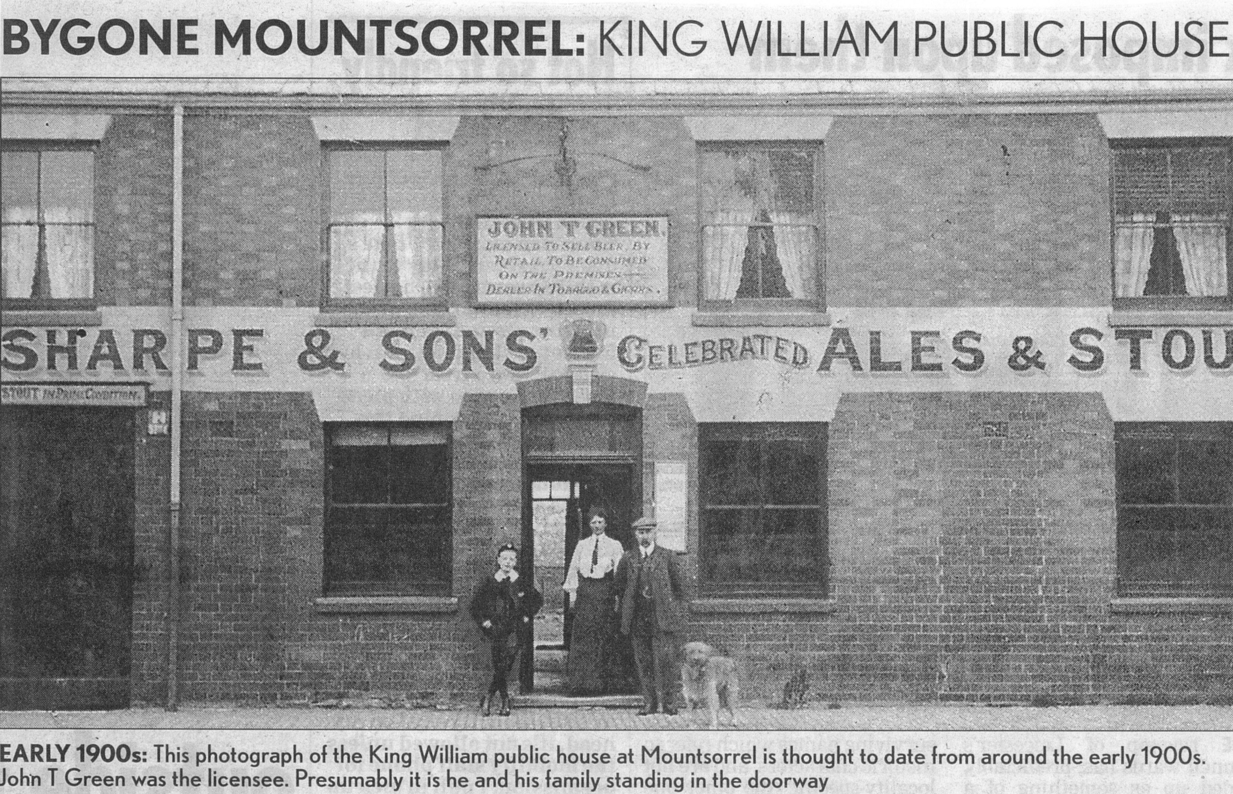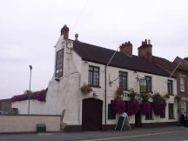
Stag & Pheasant (c1912 – landlord J. T. Green) Stag & Pheasant
(Note – this photograph is ERRONEOUSLY labeled as
the ‘King William’)

Location – 152 Leicester Road (next to the ‘King William IV’).
Brewery – Stretton’s Brewery Ltd., Derby.

Stag & Pheasant landlords –
1871 William Groves
1875 -78 John Hewitt (victualler)
1880 William Snow Johnson (victualler)
1881 Edward Robinson
1883-84 Philip Ball Jnr. (victualler)
1887-1908 William Johnson (victualler)
1912 -16 John Thomas Green
1922-25 John Hickling
  - John Wilson

DEMOLISHED

