Olive Branch – Clipsham

(Note – details reflect research to date and that the records for missing dates are not currently available)

Note –
A number of sources record that the ‘Olive Branch’ in Clipsham began in 1890 when three farm cottages
were converted to form the pub. However, an ‘Olive Branch’ public house in Clipsham is listed in trade
directories as early as 1846.

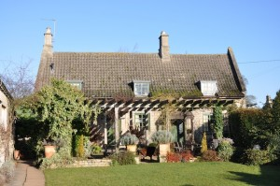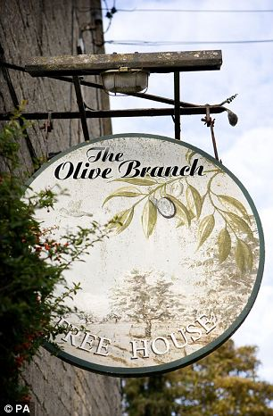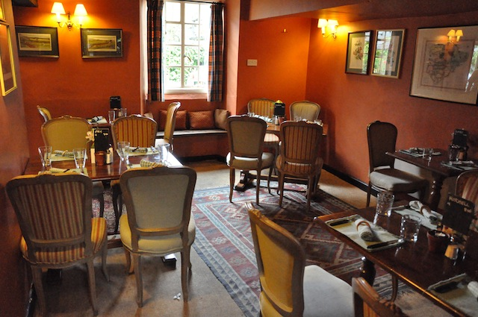
Olive Branch Olive Branch (sign) Olive Branch (Interior 1)

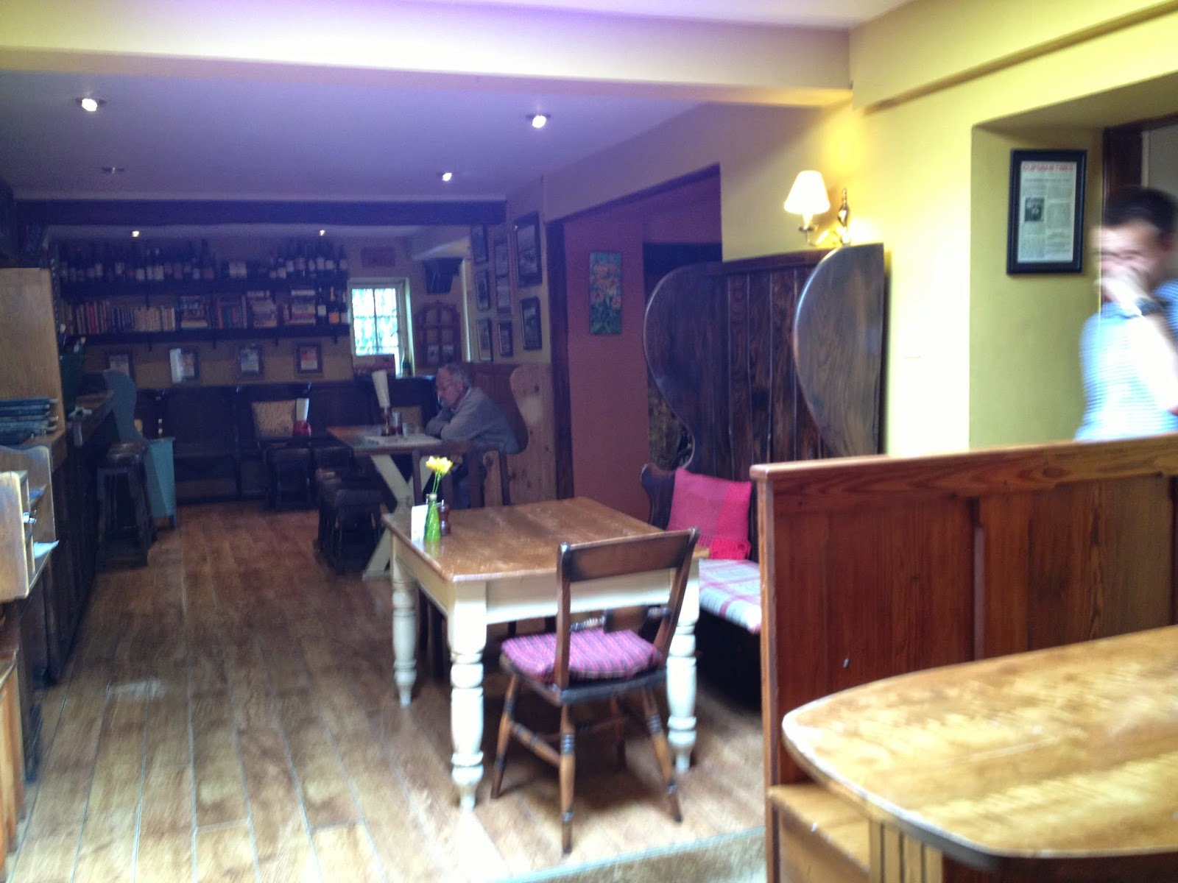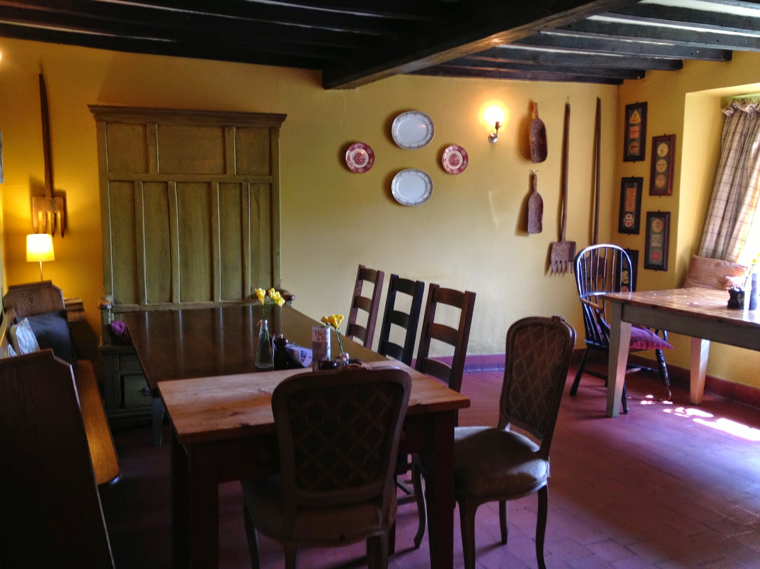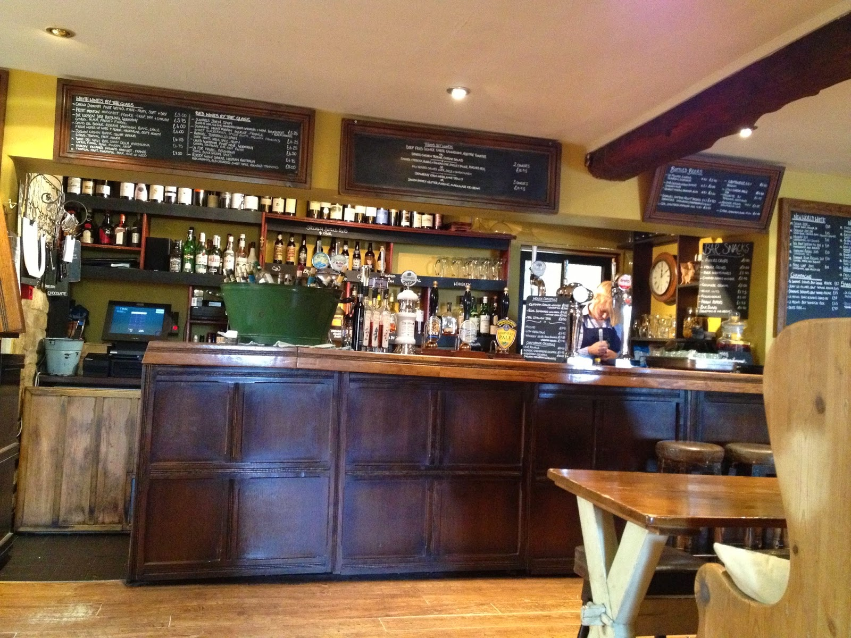
Olive Branch (Interior 2) Olive Branch (Interior 3) Olive Branch (Interior 4)

Location – Main Street.
Brewery – Olive Inns.

Olive Branch landlords –
- John Howitt (victualler)
  - Elijah Howitt (victualler)
- Robert Parker
  - William Merry (beerhouse keeper & farmer)
- Alfred E. Willson

2016 Ben Jones & Sean Hope

