Hinckley Liberal Club – Hinckley

(Note – details reflect research to date and that the records for missing dates are not currently available)

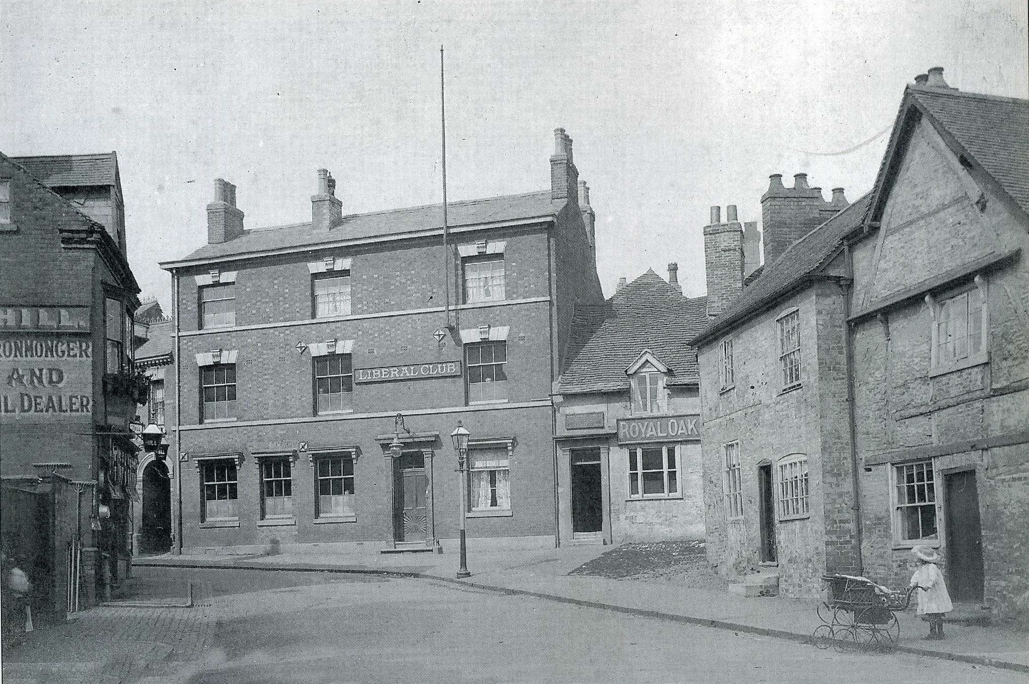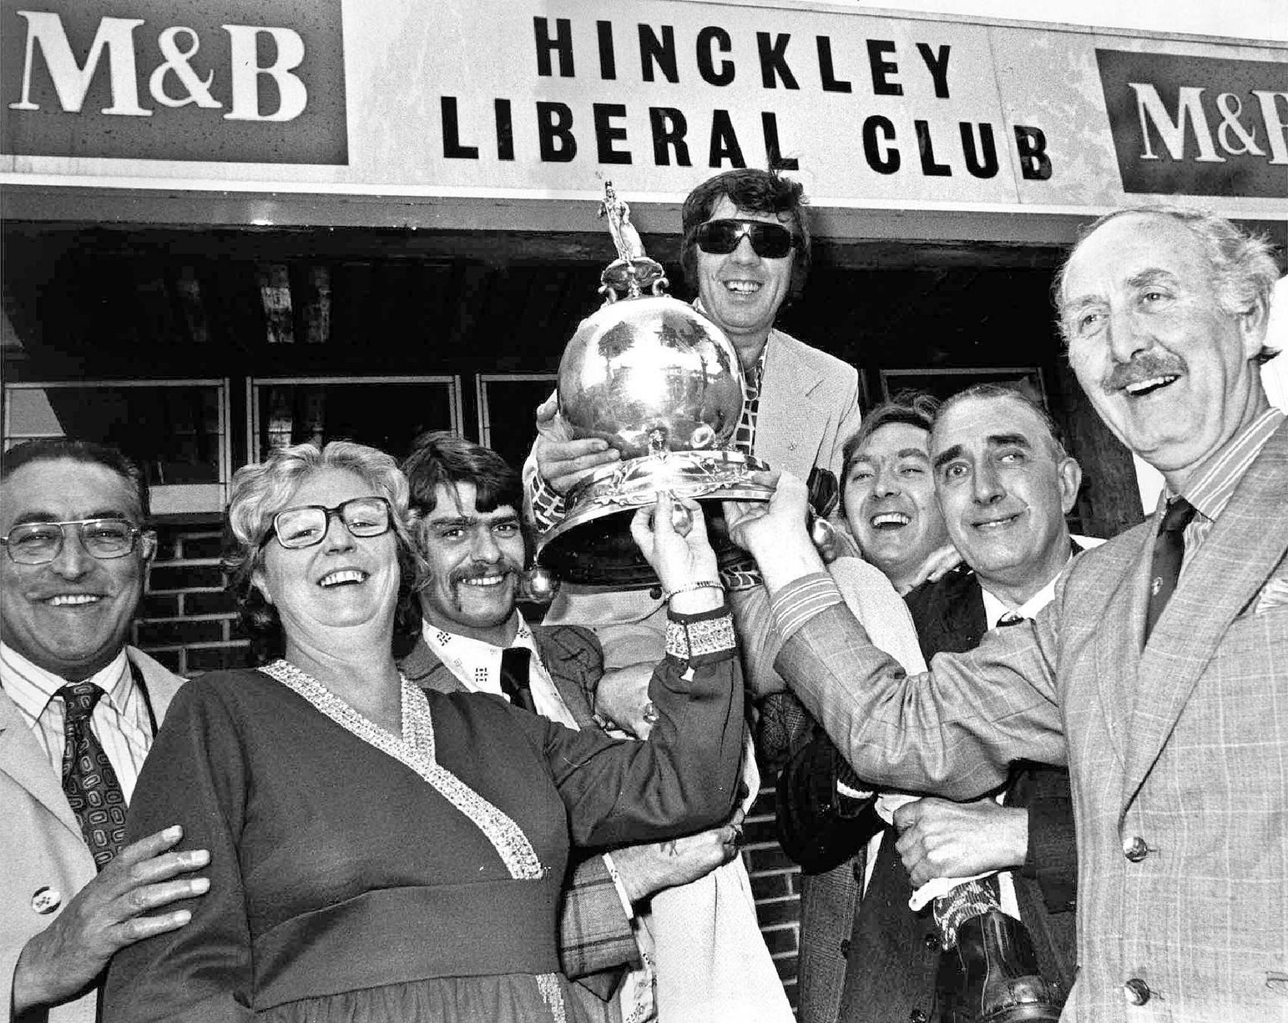
Hinckley Liberal Club (& Royal Oak – c1905) HLC (Norman Dagley celebrating the winning
of the World Billiards Championship in the 1970’s)

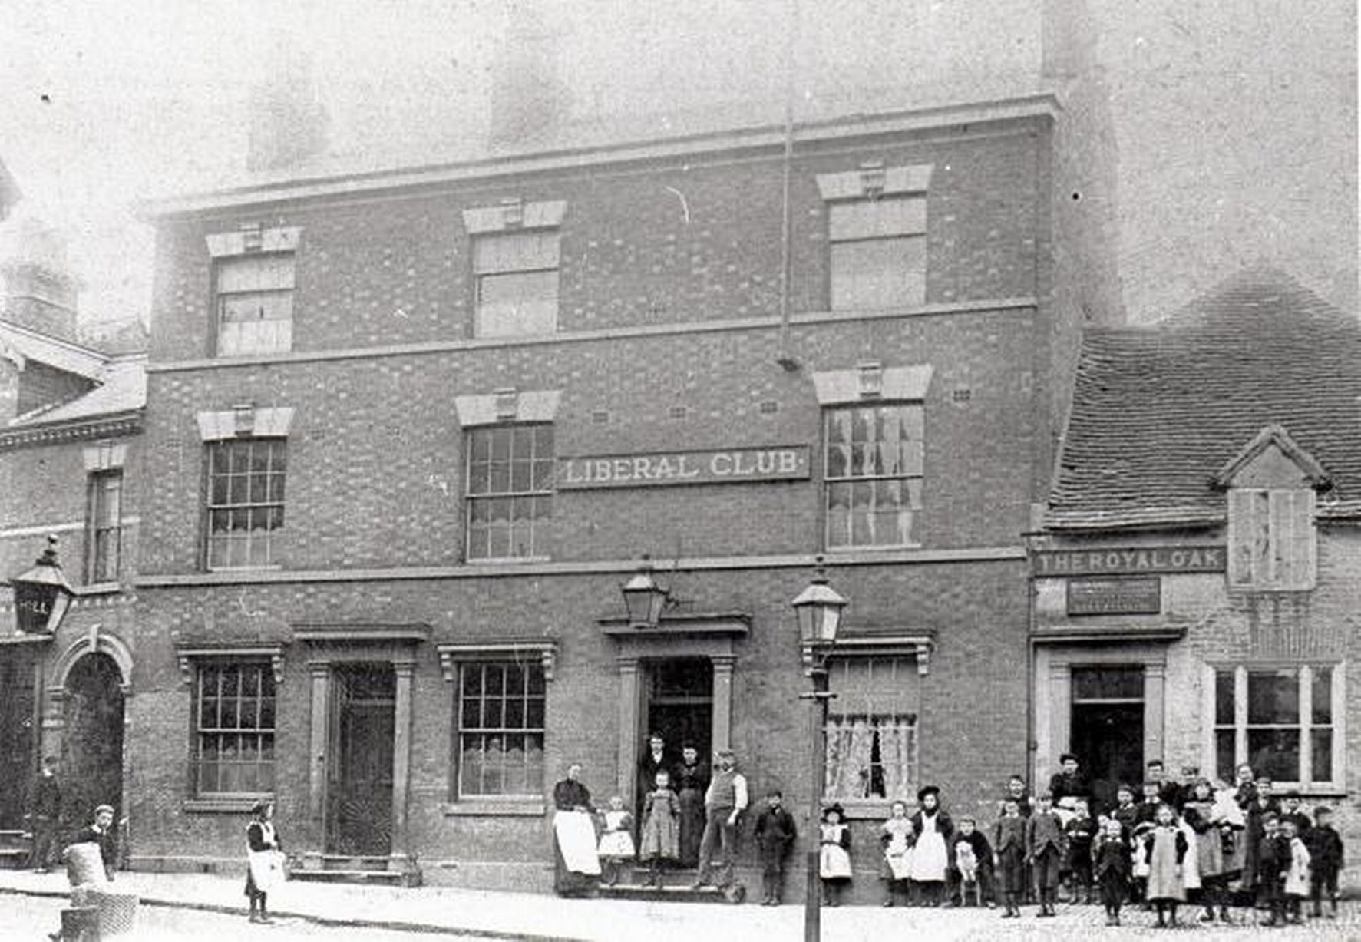
Hinckley Liberal Club (% Royal Oak)
Location – 28 Mansion Street.

Hinckley Liberal Club stewards –
- Arthur Taylor (sec.)
- W. Bott (sec.)
1899 John Atkin (sec.) George Russell (manager)
1901-02 ‘Hinckley Liberal Club’ listed but no landlord named
1908-16 William Dilley (sec.)
(Note – the 1912 & 16 Directories list the address as ’12 Mansion St’)

DEMOLISHED

