Lion & Lamb Hotel

(Note – details reflect research to date and that the records for missing dates
are not currently available)

Note –
In Christian heraldry, the lion is the symbol of the resurrection, and the lamb is the symbol of the redeemer.
However, in its early days this ‘Lion & Lamb’ became a centre of dissent, where the ‘Revolution Club’
held fortnightly meetings.
In 1788 the ‘Lion & Lamb’ (and two other pubs) catered for over 670 diners celebrating the centenary of
the landing of William of Orange.

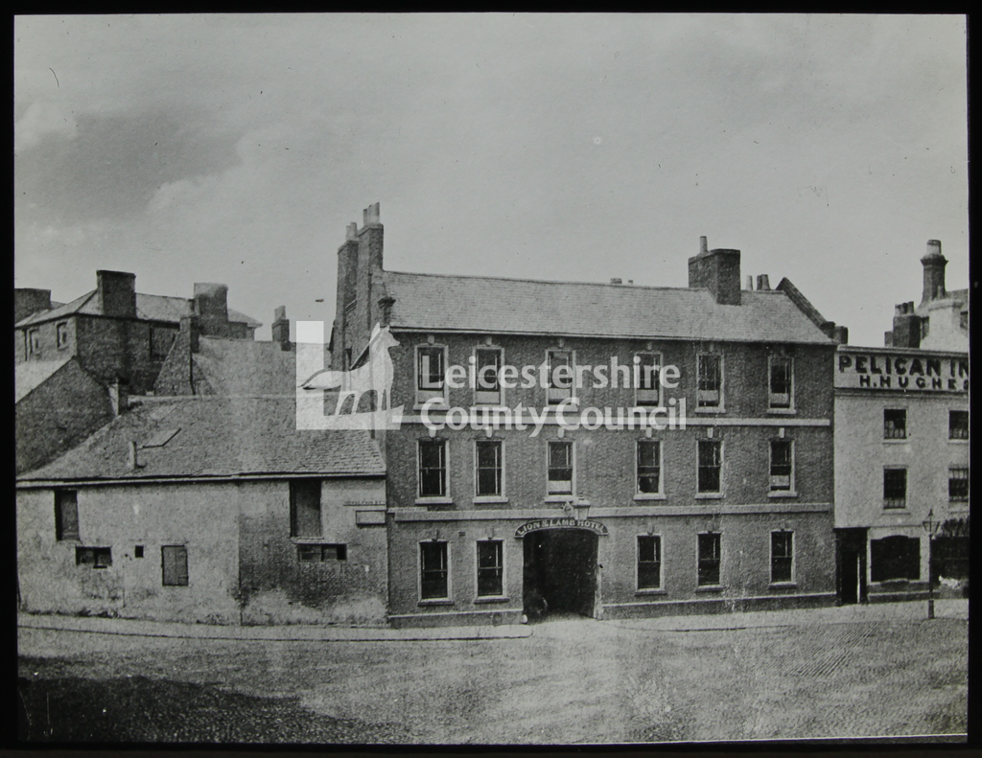
Lion & Lamb Hotel (and Pelican) (Leicestershire County Council)

Location – 51 Gallowtree Gate – Southwest side between Victoria Parade & Horsefair Street.

Lion & Lamb Hotel landlords –
1740’s RE-BUILT
1790 Joseph Atwell
1794 Richard Glover
1815 -47 Henry White
(Note – one Directory for 1841 also lists ‘William Henry Turnham’ as landlord of the ‘Lion & Lamb’)
1854 Henry A. Thompson
(Note – the 1854 Directory lists the name as ‘Lion & Lamb Commercial Inn’)
1855 -70 Robert Burnham (victualler)
(Note – the 1867 Directory lists the name as the ‘Lion & Lamb Hotel’)
1873-75 Henry Flude (victualler)
1876 Henry Flude jnr.
1877-78 Henry Flude (victualler)
(Note – the 1878 Directory lists Henry Flude as landlord of both the ‘Lion & Lamb’ & the
‘Lion & Dolphin’ in the Market Place)
1881 George Alfred Meadows

The ‘Lion & Lamb’ is not listed after 1881.
DEMOLISHED

