White Hart – Quorn

(Note – details reflect research to date and that the records for missing dates are not currently available)

Note –
Now much altered, the ‘White Hart’ is the oldest pub in Quorn, dating from 1690, and, at one time, had its
own brewhouse.

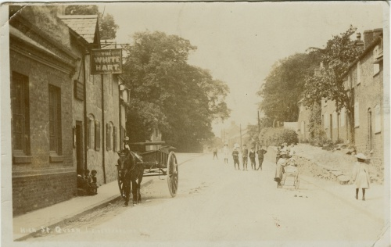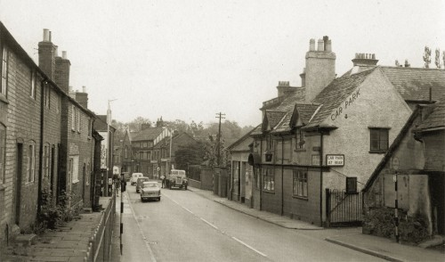
White Hart White Hart
(1909 – Quorn Museum – Sue Templeman) (1960’s – Quorn Museum – Andrew Webster)

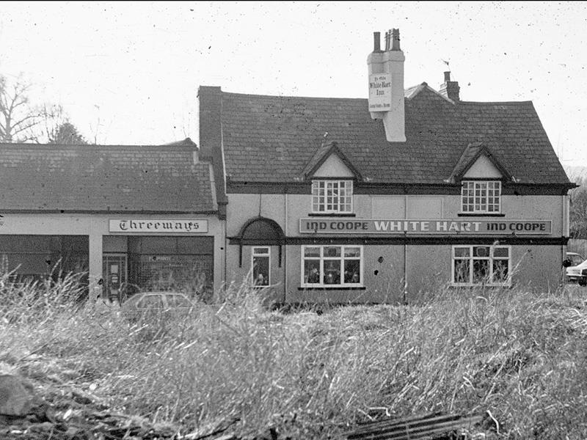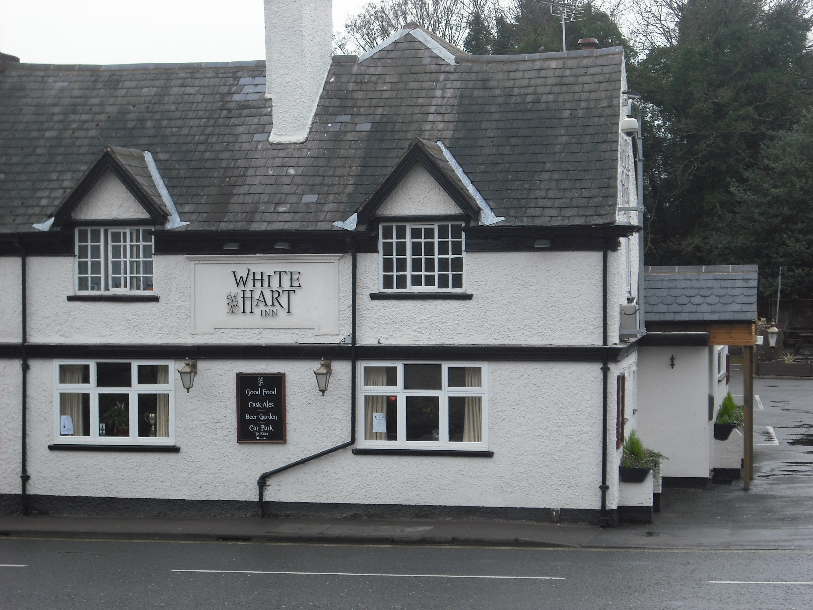
White Hart White Hart

Location – 32 High Street.
Brewery – All Saints Brewery, Leicester / Free House.

White Hart landlords –
  - John Williams
1835-41 Ann Williams
  - James Rumsby [Rumsley] [Rimsley] (victualler, brewer, farmer, maltster & dealer in hops)
1901-02 ‘White Hart Inn’ listed but no landlord named
1908 Joseph Cooper Needham
1912-16 Reuben Taylor
1922-36 Frank Bream
1941 Ernest Bradley
1967-75 Albert & Elsie Sweet

