White Lion Inn – Whissendine

(Note – details reflect research to date and that the records for missing dates are not currently available)

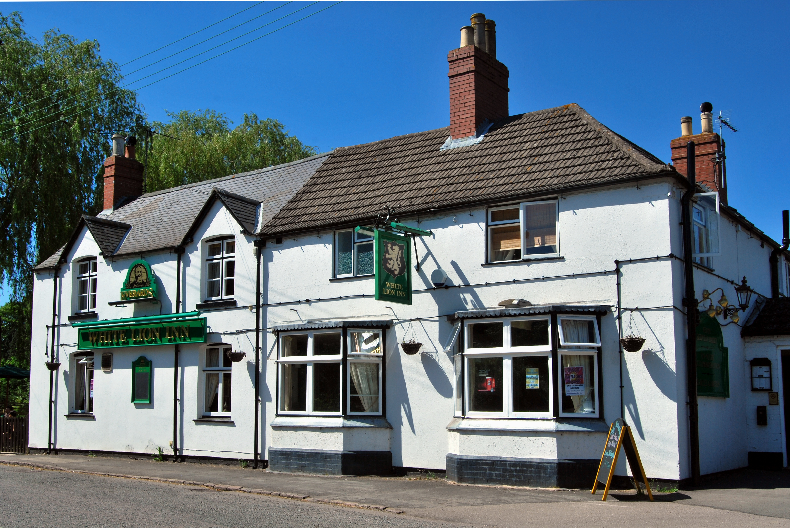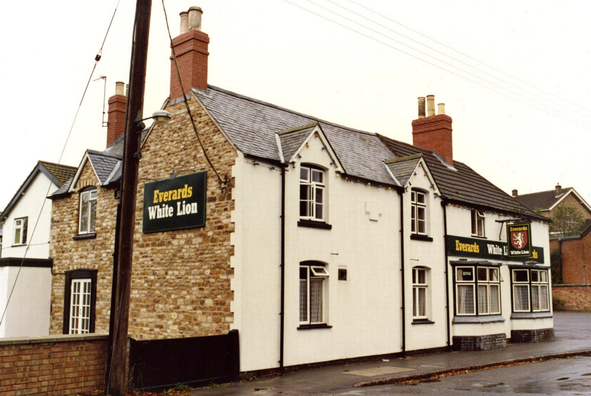
White Lion Inn White Lion Inn

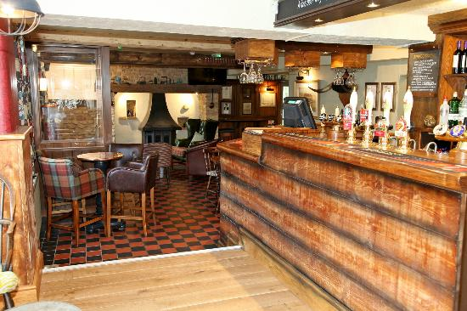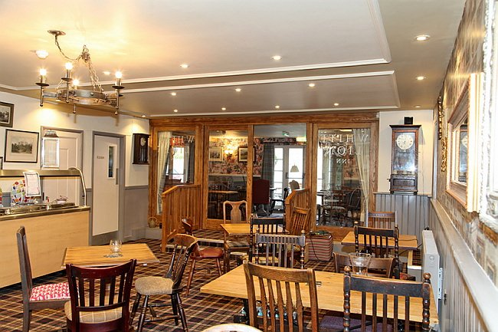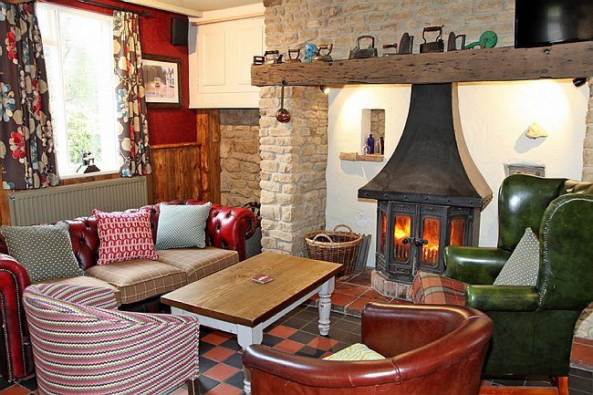
White Lion Inn (Interior 1) White Lion Inn (Interior 2) White Lion Inn (Interior 3)

Location – 38 Main Street.
Brewery – Langham Brewery / Everards, Leicester.

White Lion Inn landlords –
  - Robert Hayes
  - John Hayes
- John Barwell (victualler)
- William Crowson
  - William Allen
- William Dexter (victualler)
- John Trenham
- Charles Beck (victualler & bricklayer)
  - Benjamin Johnson (victualler & rate collector)
- George William Knowles
  - William Harding (victualler & ale & porter merchant)
  - Tom Roger Hugh Bailey
1916-32 Arthur Dyer
1936-41 Arthur Godfrey Brown

2013-18 Yolanda Rees & Chris Stevenson

