Terrace

(Note – details reflect research to date and that the records for missing dates are not currently available)

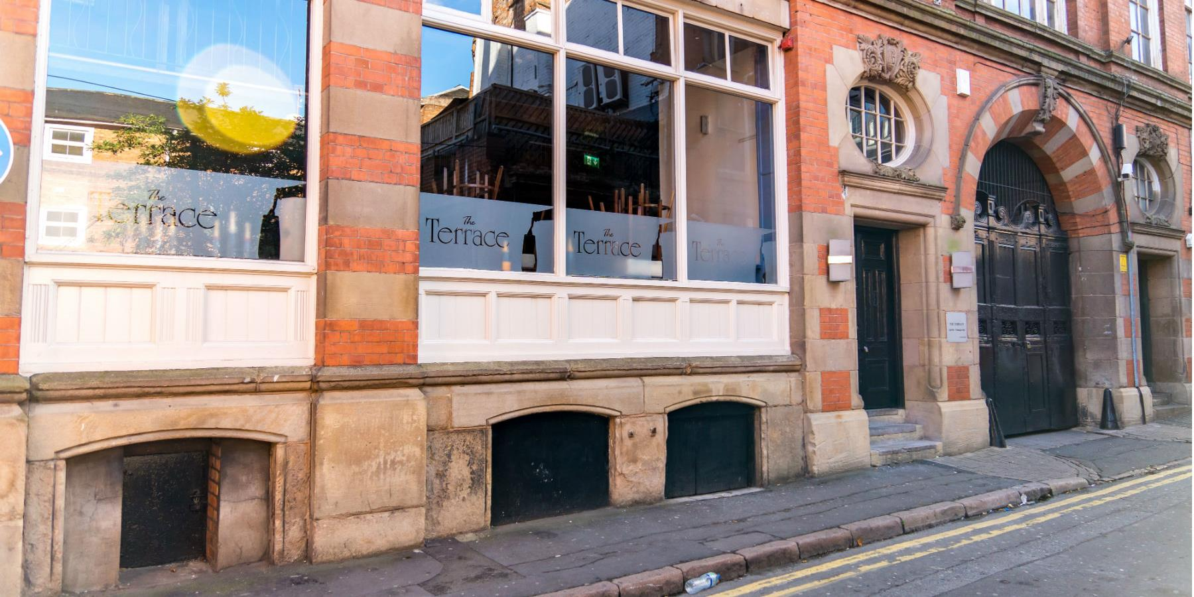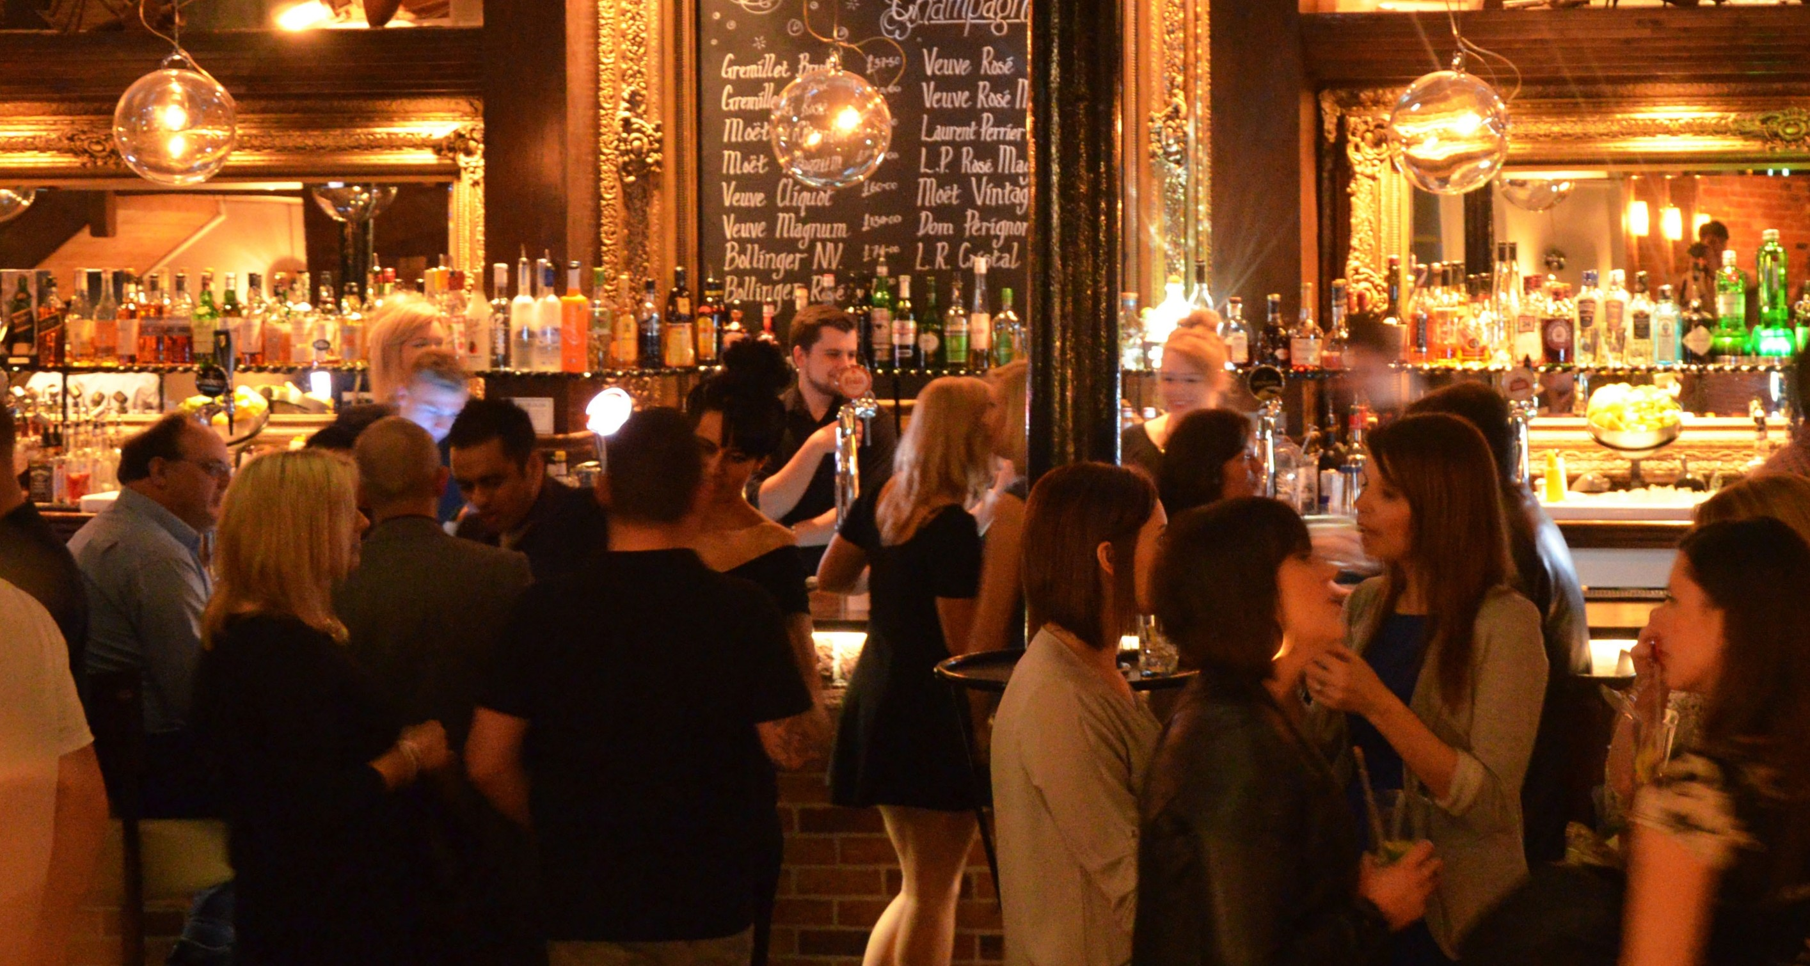
Terrace Terrace (interior)

Location – 1 Albion Street – Southwest side between Chatham Street & Belvoir Street..

Terrace landlords –

