Three Crowns

(Note – details reflect research to date and that the records for missing dates
are not currently available)

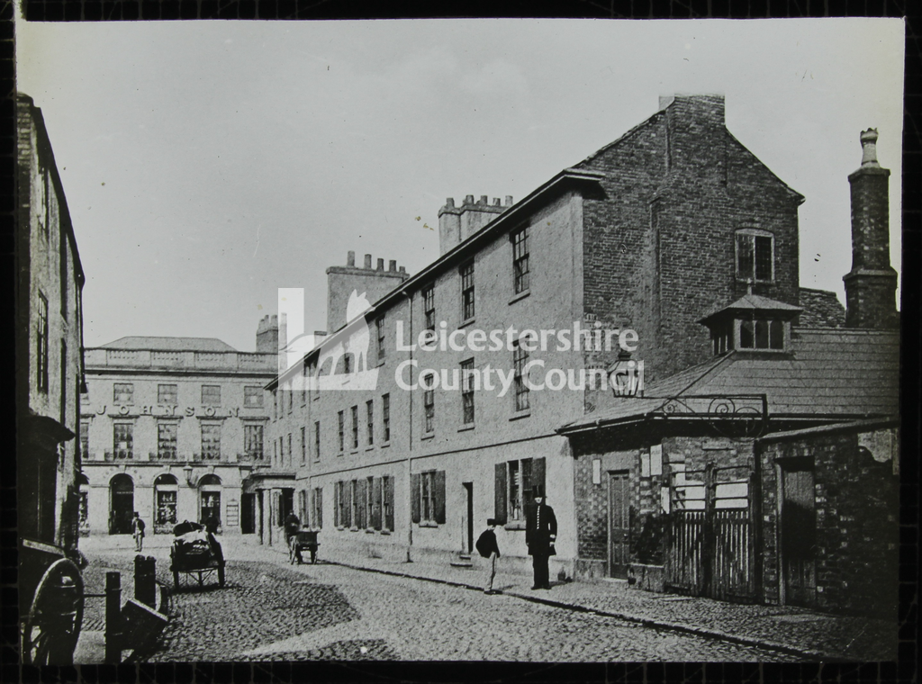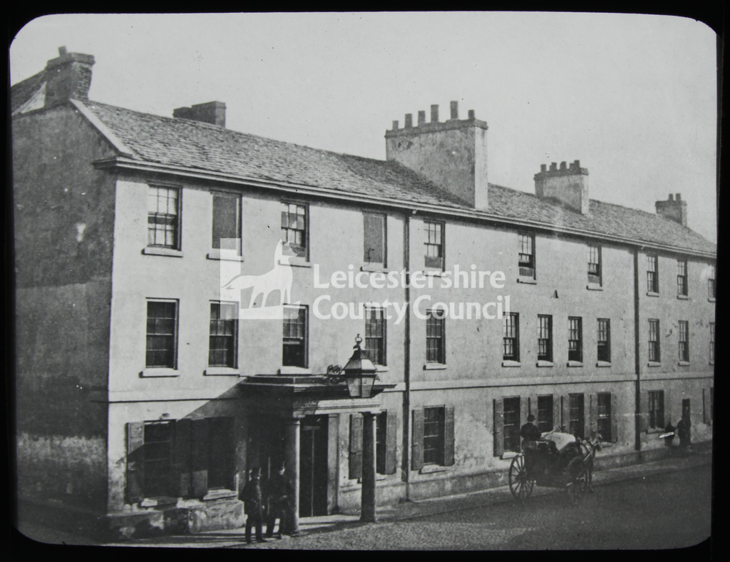
Three Crowns Hotel Three Crowns Hotel
(Leicestershire County Council) (Leicestershire County Council)

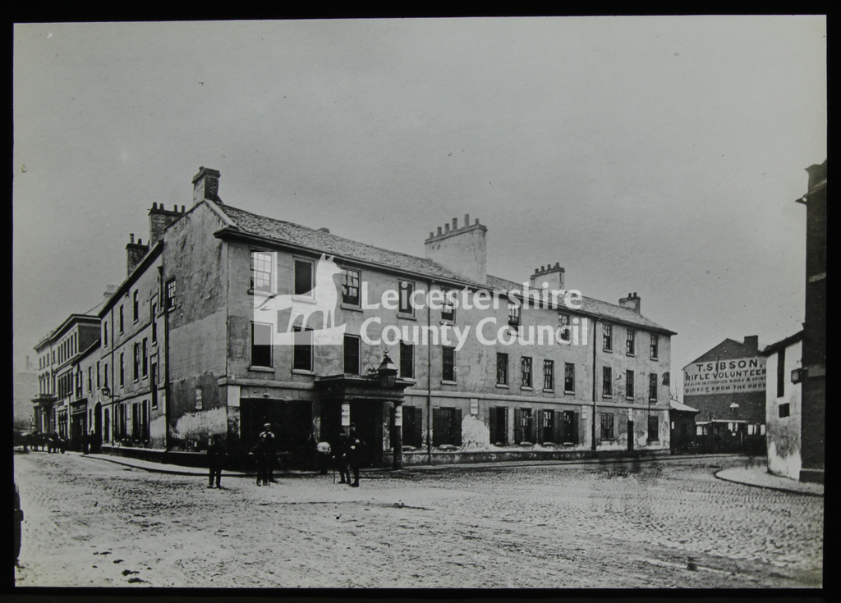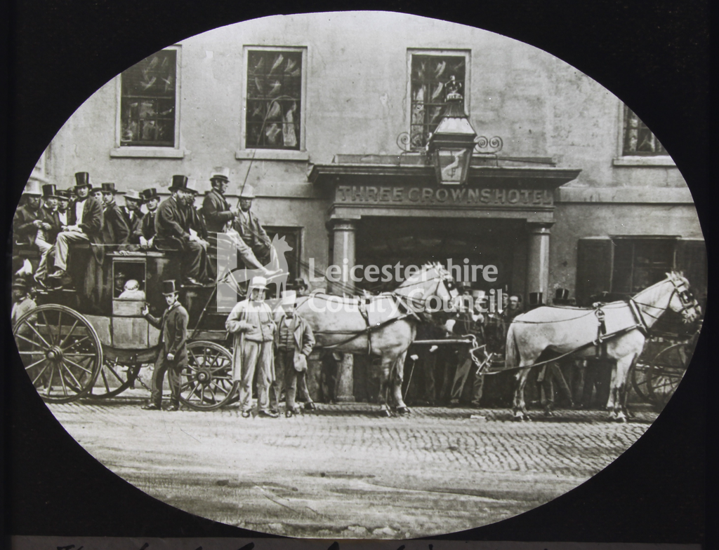
Three Crowns Hotel (& Rifle Volunteer) Three Crowns Hotel
(Leicestershire County Council) (1866 – the last coach out of Leicester [to London])
(Leicestershire County Council)

Note –
During the 18th century, the ‘Three Crowns’ was the venue for the annual Corporation banquet, which for
a period was named the ‘Venison Feast’. In 1762 this was reported as “an elegant entertainment
provided for 395 persons in commemoration of the defeat of the boasted invincible Spanish Armada, in
the reign of Queen Elizabeth, and thereby the delivery of this nation from Popery and slavery”.
By 1766 the number of guests at the annual Venison Feast at the .Three Crowns’ had risen to 480.

This public house was on the corner of Horsefair Street and Granby Street, but is variously listed at
Granby Street, Horsefair Street or Gallowtree Gate).

Location – 1 Granby Street – Southwest side between Horsefair Street & Bishop Street.

Three Crowns landlords –
- The ‘Crown’ renamed the ‘Three Crowns’.
- Note - the Corporation banquet was held at the ‘Three Crowns’ on 19th August, where over a
Hogshead of ale (approx 54 gallons) was consumed.
- ‘Three Crowns Inn & Coffee House’ listed but no landlord named.
(Note – ‘William Bishop’ is listed as ‘post-chaise keeper’ at the ‘Three Crowns’)
1815-35 Willoughby James Bishop
(Note – the 1835 directory lists the address as ‘Horsefair Street’)
1841-43 William Wright Pell (Three Crowns & Posting House)
1846 -47 William Beavington (Three Crowns Hotel)
1854 Thomas Freer (Three Crowns Hotel)
1855 T. Mills
1861-67 Mrs. Sarah Carter (victualler) (Three Crowns Commercial Hotel & Posting House)

Note – the ‘Three Crowns’ was DEMOLISHED in 1867 to make way for a new bank.

