Hotel Maiyango

(Note – details reflect research to date and that the records for missing dates
are not currently available)

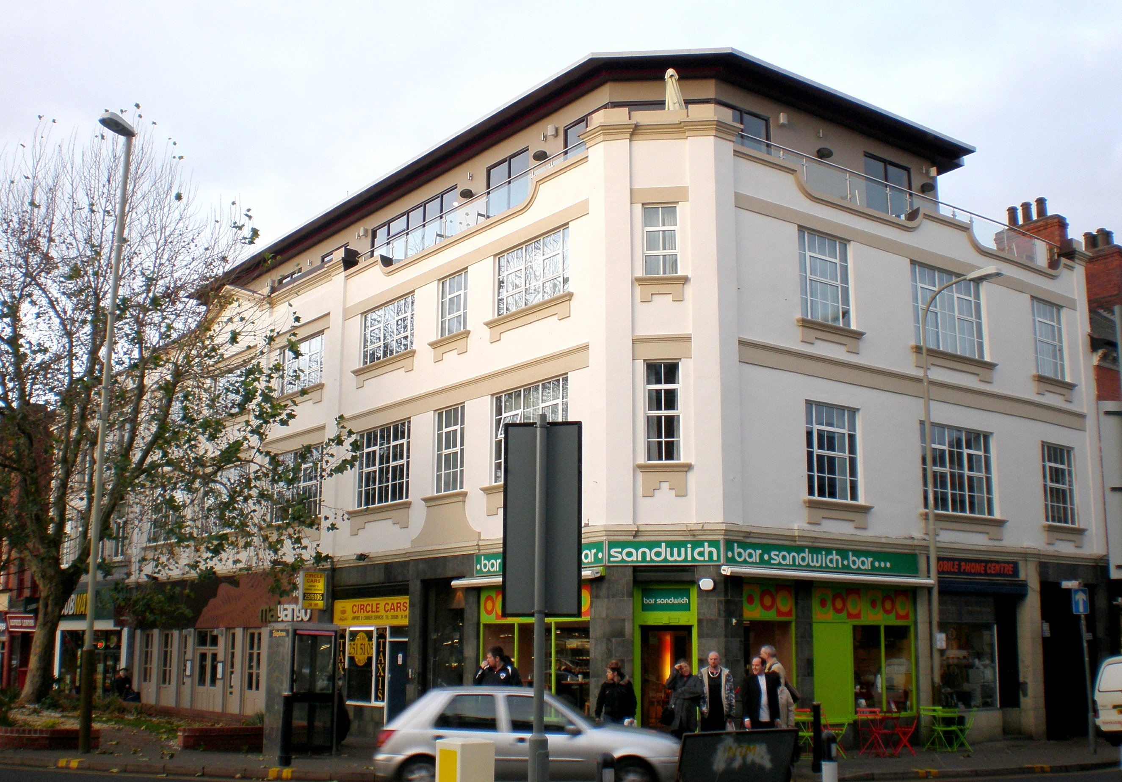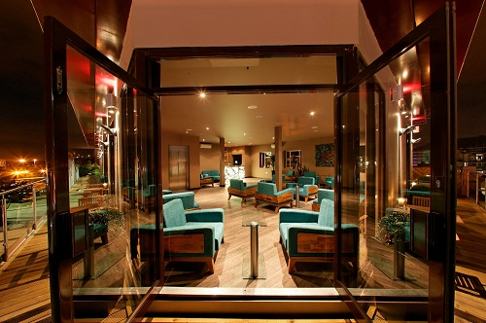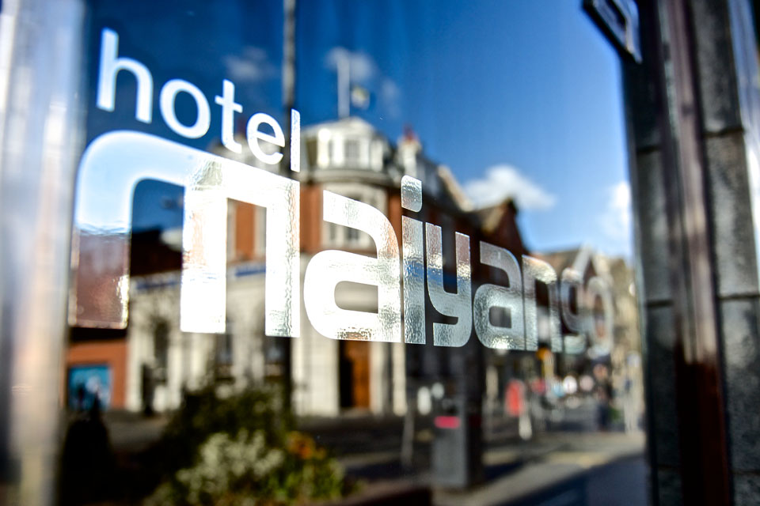
Hotel Maiyango (Ned Trifle) Hotel Maiyango (Interior) Hotel Maiyango (sign)

Location – 13-21 St. Nicholas Place (Street) – North side between Highcross Street & Vaughan Way.

Hotel Maiyango landlords –

