White Horse Inn – Morcott

(Note – details reflect research to date and that the records for missing dates are not currently available)

Note –
The ‘White Horse Inn’, listed from the mid 18th century, was a coaching inn on the Market Deeping to
Oakham Turnpike.

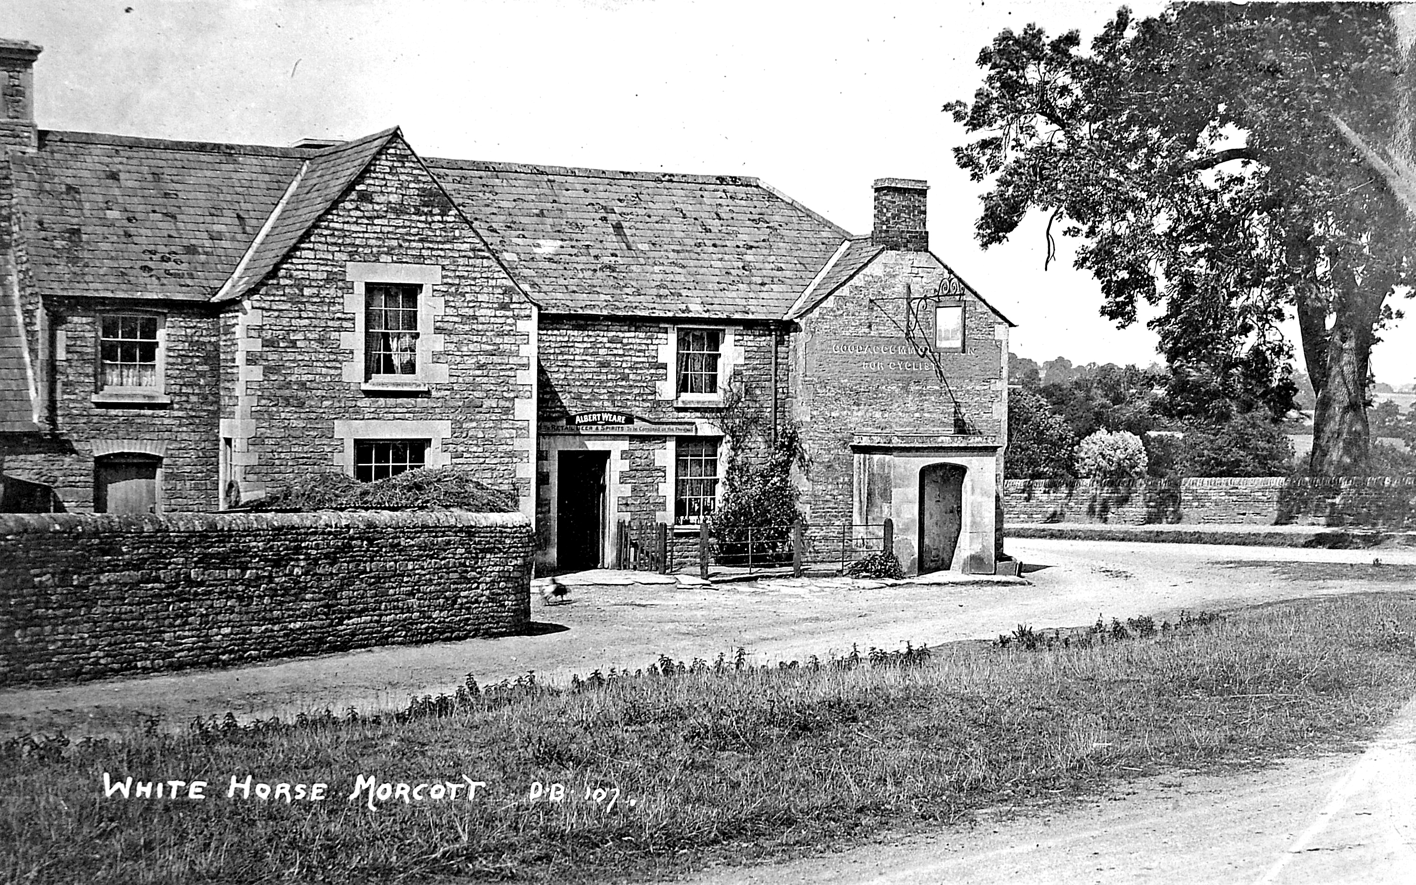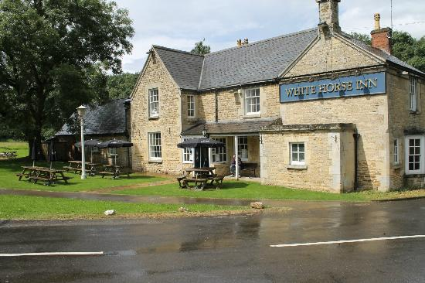
White Horse Inn (c1930) (Anthony Martin) White Horse Inn

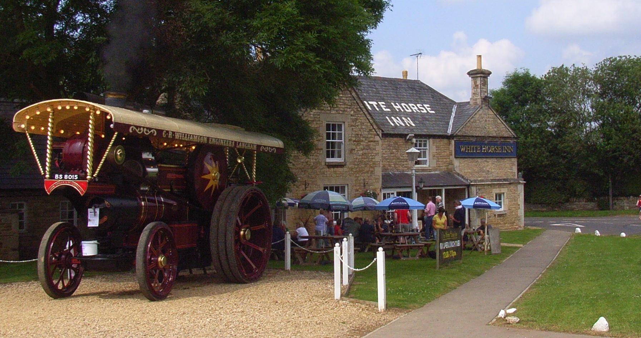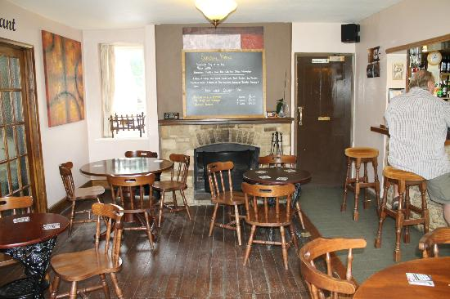
White Horse Inn White Horse Inn (Interior)

Location – 1 Stamford Road.

White Horse Inn landlords –
1841 William Henry Scott
- Thomas Wyatt (victualler)
  - George Scott
- Adam Scott (victualler)
  - William Warren Springthorpe (victualler & farmer)
- Mrs. Elizabeth Buckle
  - William Isaac Curzon (victualler)
1901 Catherine Southwell
- Charles Weare
1911-30 Albert Weare
- Mrs. Harriet Weare
- Edward Thompson
- William ‘Quality’ Thompson
  - Frank L. Logsdon
1956 Mr. Bradley
1957 William Green
1961 Mr. Davis
1961 Peter Bleasdale
1965-66 Mr. Robinson
1966 John Chandler
1975 Russ Stones
1992 Reno Carrera
1995 Ernie Lowther
1997 Mr. McIntosh
1998 Terry Lyons
2001-04 Barry -----
2005 CLOSED
2006-14 RE-OPENED under the management of the ‘Boot & Shoe’ at South Luffenham
2015-16 Burghley House Preservation Trust (owners)

CLOSED

