Anchor Inn – Burbage

(Note – details reflect research to date and that the records for missing dates are not currently available)

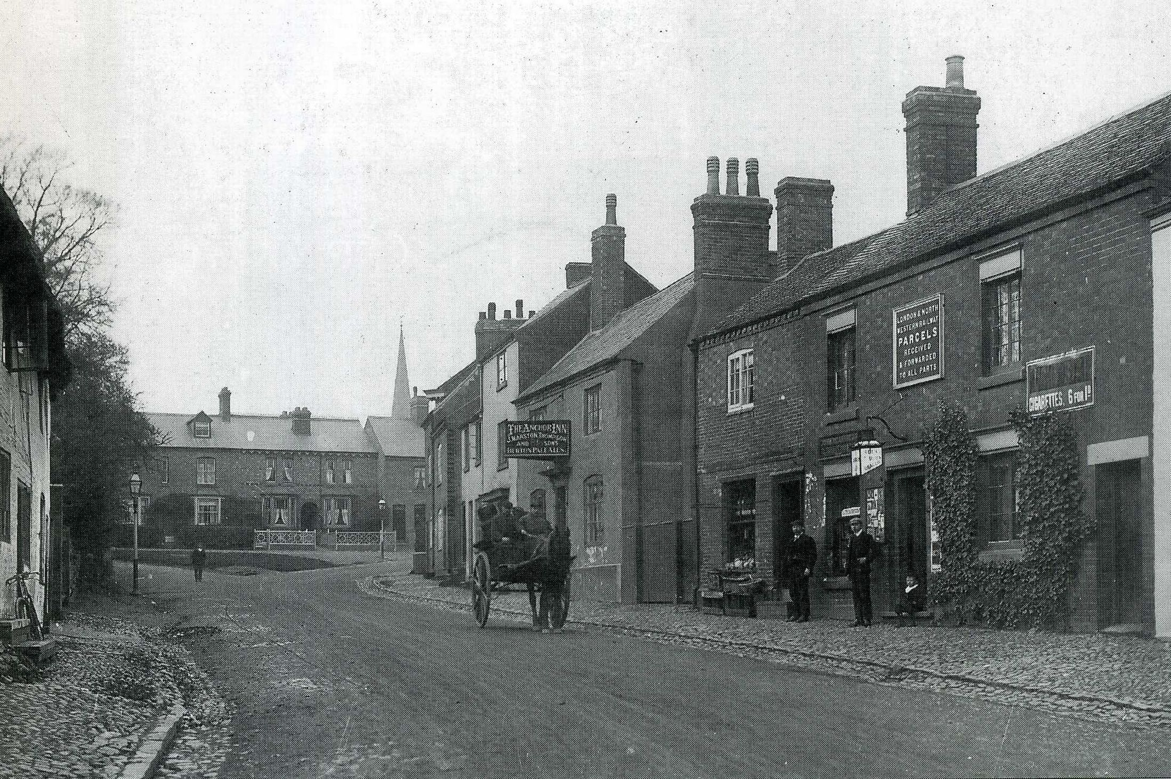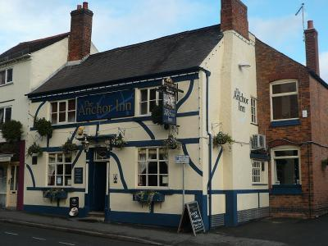
Anchor Inn (1906) Anchor Inn

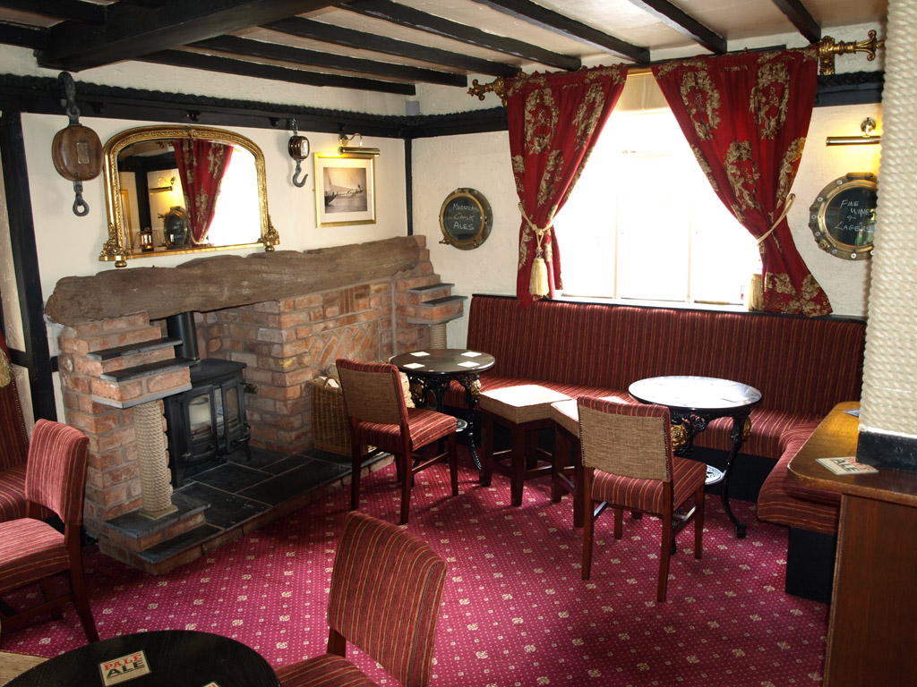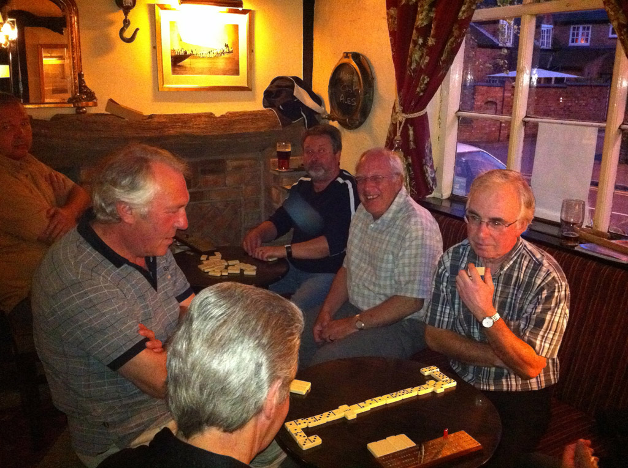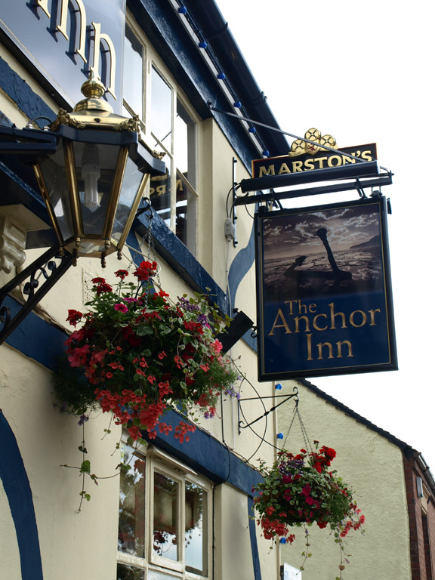
Anchor Inn (Interior 1) Anchor Inn (Interior 2) Angel Inn (sign)

Location – 63 Church Street.
Brewery – Marston’s, Burton-upon-Trent.

Anchor Inn landlords –
1828-61 Thomas Perkins (& butcher)
1862-76 James Hudson
1877 Edward Wightman
1880 John Orton (victualler)
1881-92 John [Joseph] Robinson Wykes (victualler, farmer & grazier)
1895-99 Mrs. Clara Wykes (victualler, farmer & grazier)
1901-02 C. Wykes
1908 John Dare
1912 Frederick Marshall
1916-25 Mrs. Ann Marshall
1932-36 William A. Wrench
1941 Charles Craythorne
1990-93 Keith & Kate Crowfoot

