Brookside Inn – Barkby

(Note – details reflect research to date and that the records for missing dates are not currently available)

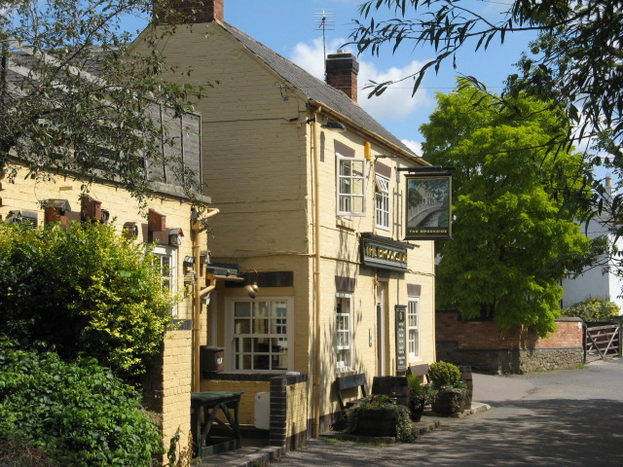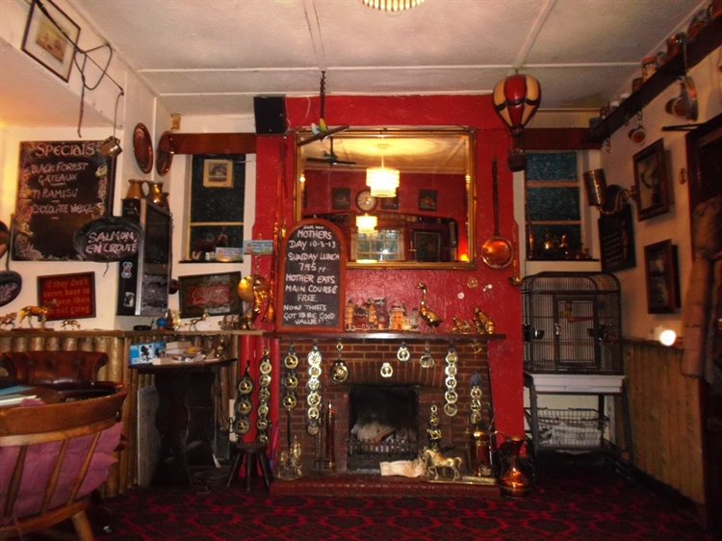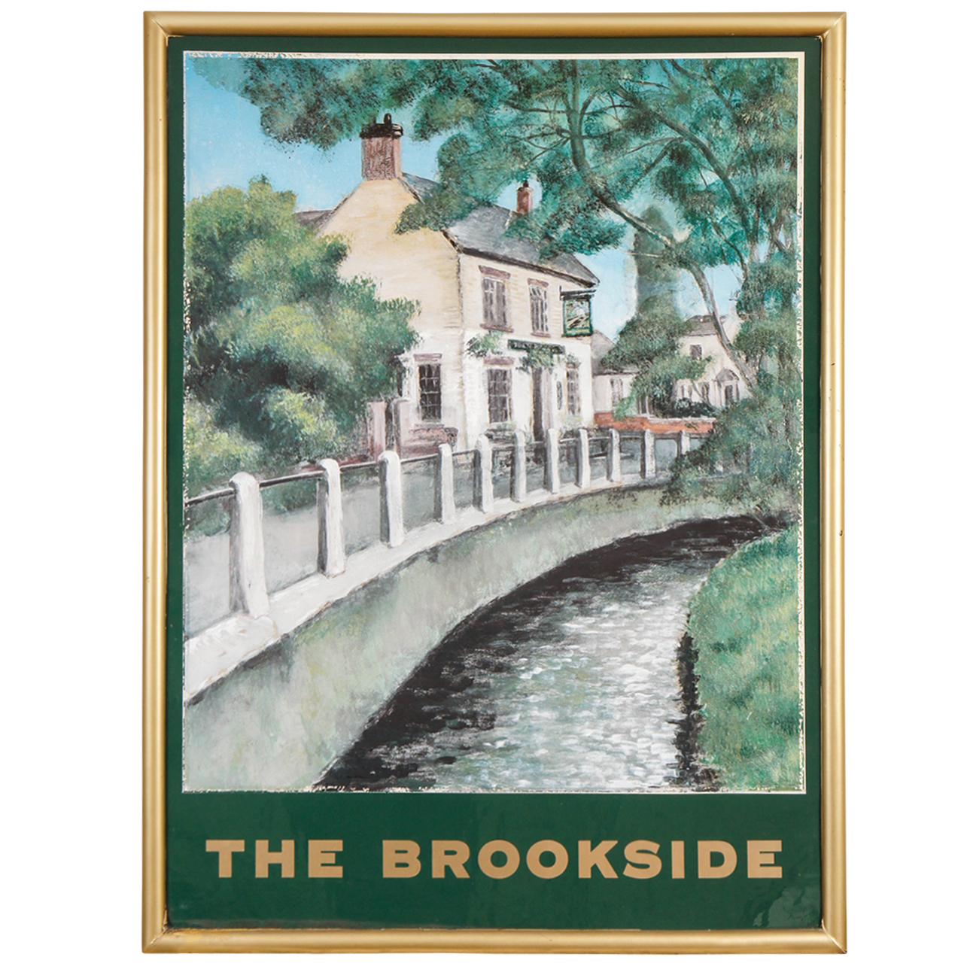
Brookside Inn (the bitterman) Brookside Inn (Interior) BI (sign)

Location – 33-35 Brookside.

Brookside Inn landlords –
  - Mrs. Eliza Norwell (beerhouse keeper)
  - James Norwell (beerhouse keeper)
1899-1912 Robert Douglas Wyatt (beerhouse keeper, assistant overseer & clerk to Parish Council)

