Quorn Country Hotel – Quorn

(Note – details reflect research to date and that the records for missing dates are not currently available)

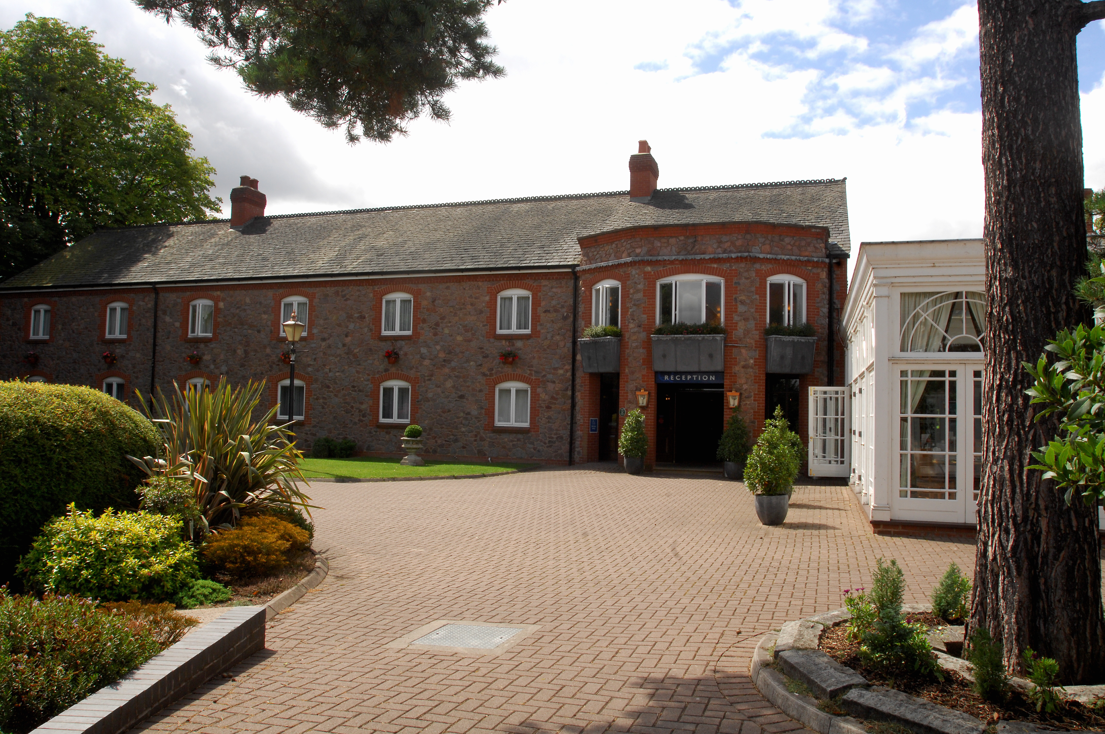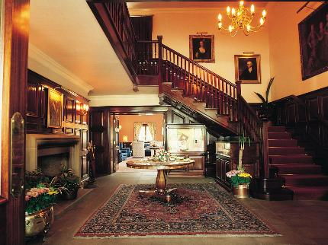
Quorn Country Hotel Quorn Country Hotel (Interior)

Location – 66 Leicester Road.

Quorn Country Hotel landlords –

