Varsity / Will’s Bar / Brewdog

(Note – details reflect research to date and that the records for missing dates
are not currently available)

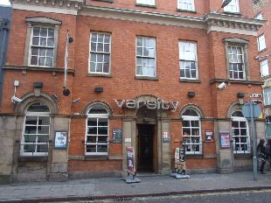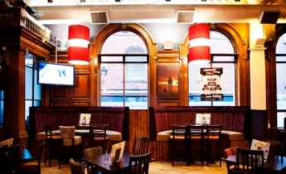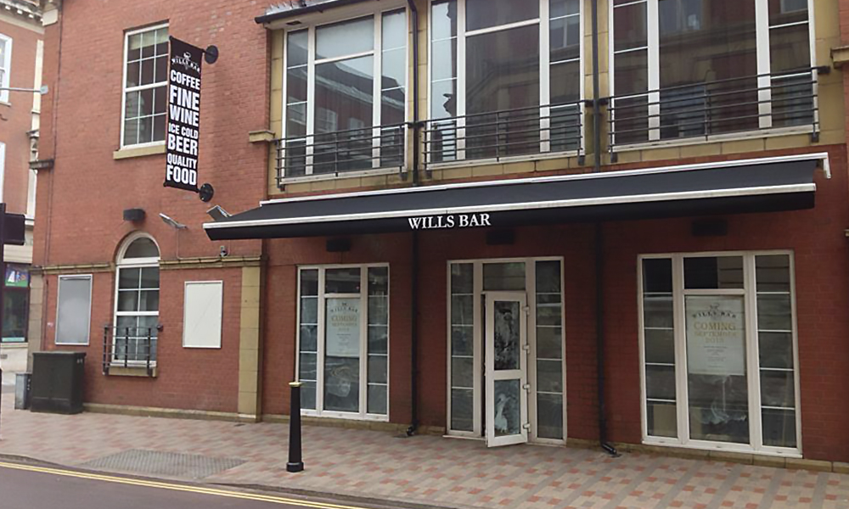
Varsity Varsity (Interior) Will’s Bar

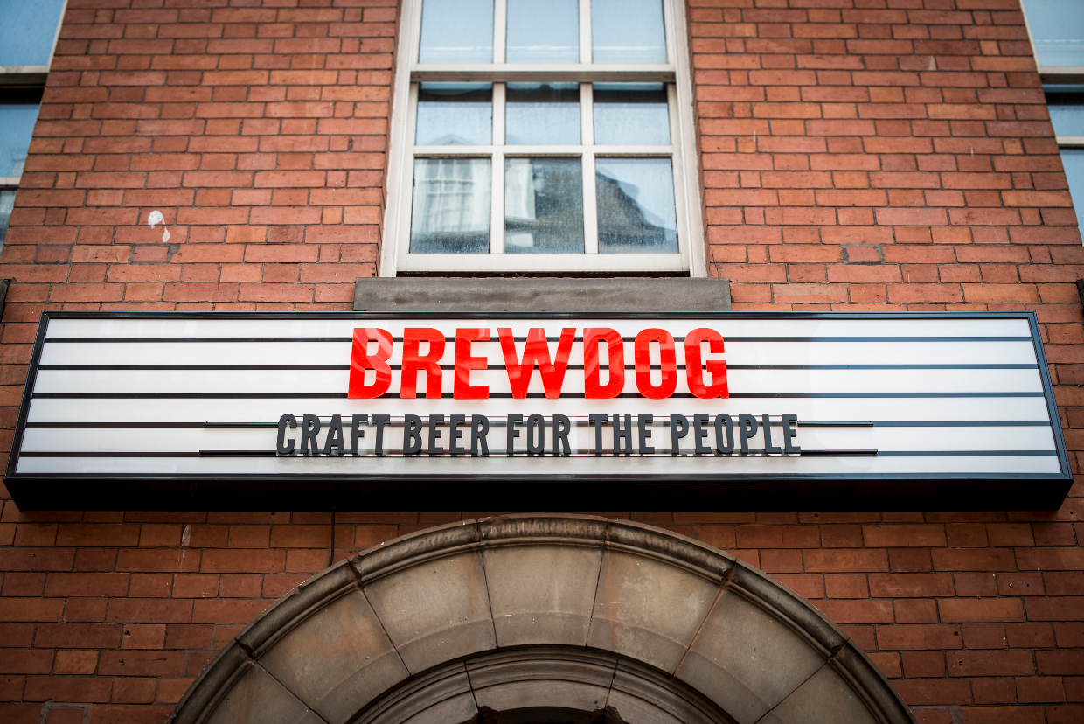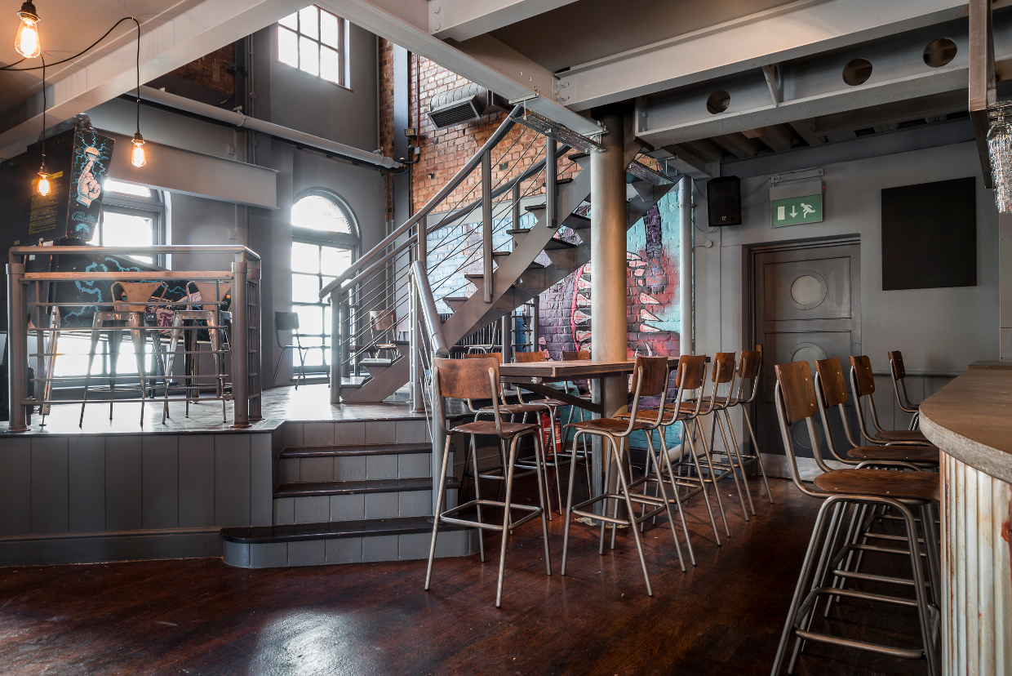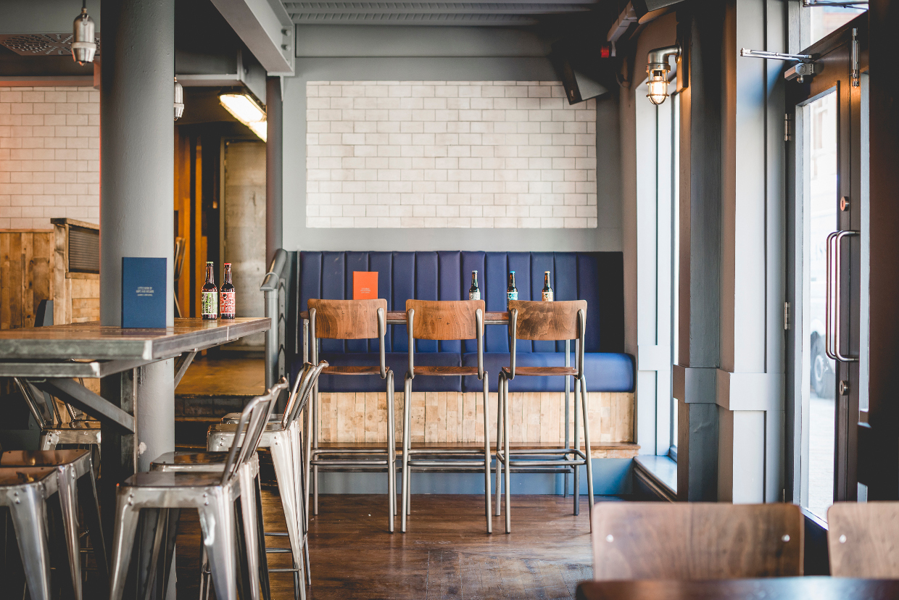
Brewdog Brewdog (Interior 1) Brewdog (Interior 2)

Location – 8 Friar Lane – Southeast side between Hotel Street & Berridge Street.

Varsity landlords –

Will’s Bar landlords –

Brewdog landlords –
2015 RE-NAMED

