Queen’s Head / Blazes

(Note – details reflect research to date and that the records for missing dates
are not currently available)

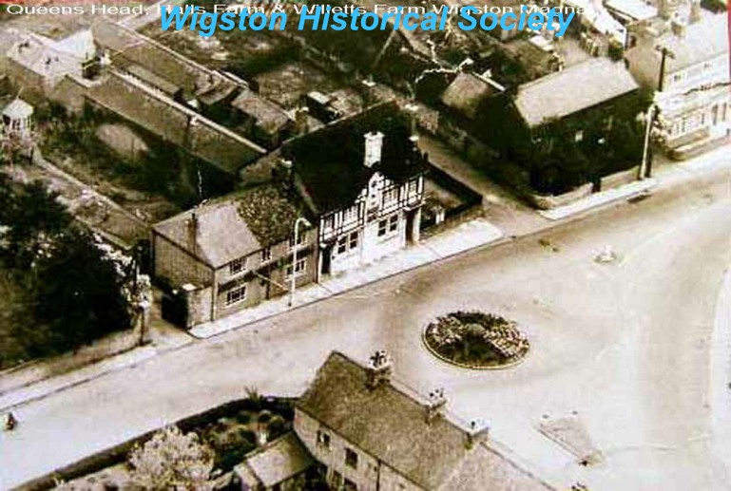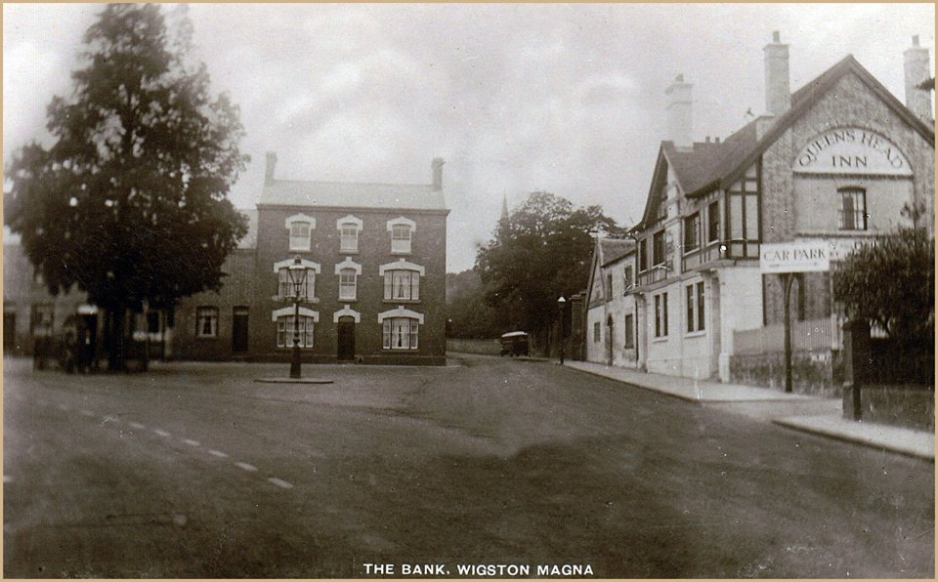
Queen’s Head (Wigston Historical Society) Queen’s Head

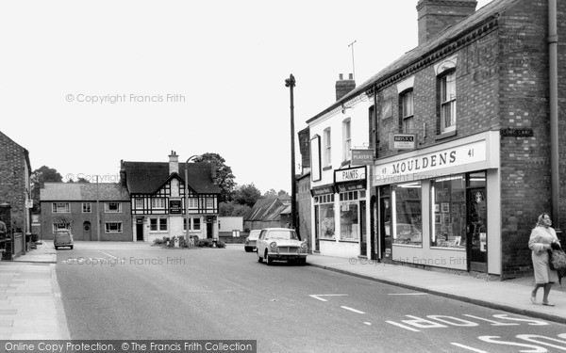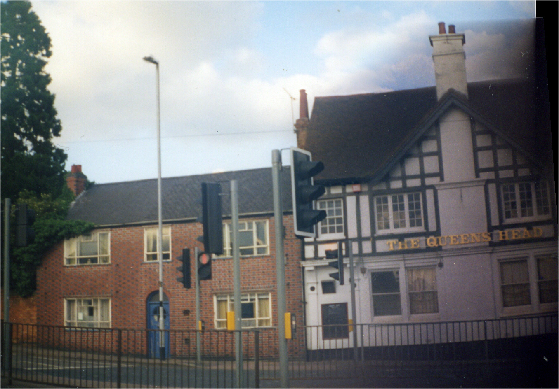
Queen’s Head (c1965 – Francis Frith) Queen’s Head (Ian Johnson)

Location – 6 Bull Head Street – East side between Church Nook & Mowsley End.
Brewery – Eady & Dulley Ltd., Market Harborough / NBC.

Queen’s Head landlords –
1812 Thomas Gillam
1846 -81 William Vann (victualler, brewer, farmer & grazier)
(Note – the 1846 Directory lists the address as ‘Bell St’)
1883-90 John Vann (victualler & builder)
1891-92 executors of Mrs. Sarah Ann Buckley (victualler)
1895 -99 Mrs. Eleanor Buckby (victualler)
1901-02 ‘Queen’s Head Inn’ on The Square listed but no landlord named
1908 Thomas Bull
1912 Harry Peake
1916 -25 George West
1932 William Cotton
1936 -41 Harry Reginald Hart

Blazes landlords –

DEMOLISHED

