Old Black Lion / Pickwick / Skandels

(Note – details reflect research to date and that the records for missing dates
are not currently available)

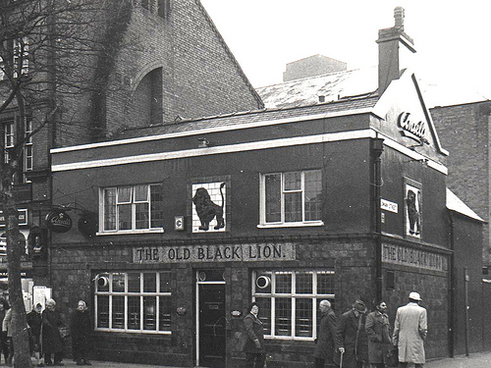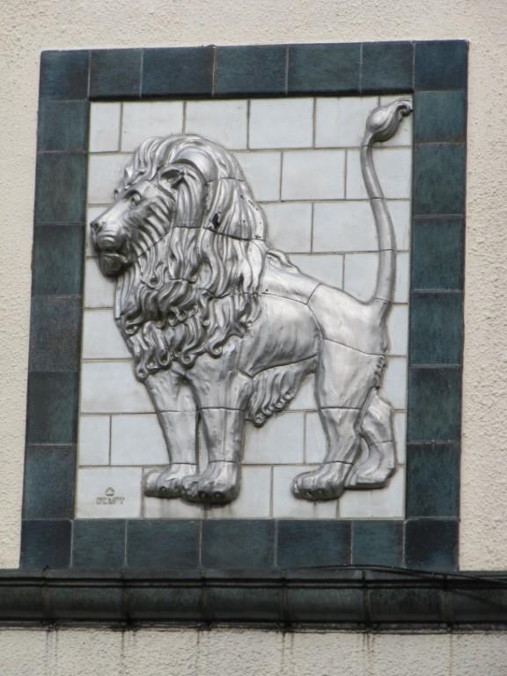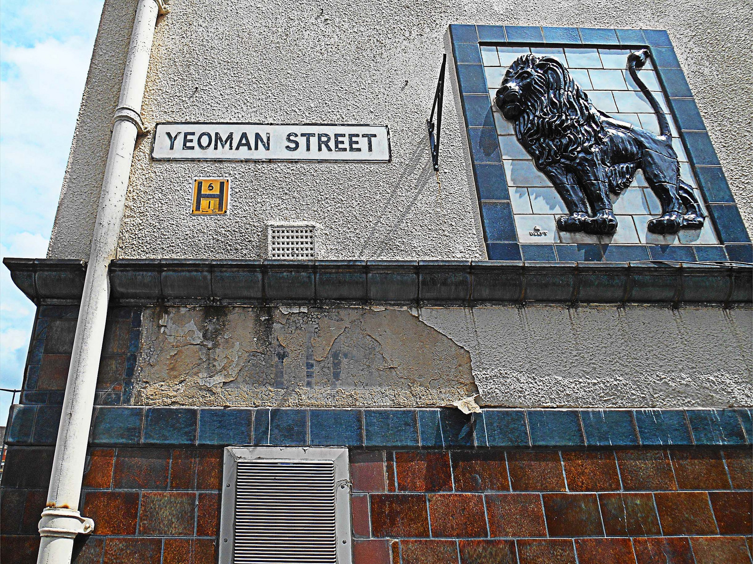
Old Black Lion OBL (sign 1) Old Black Lion (sign 2 – Chris Pyrah)
(1981 – Chris Pyrah)

Location – 73 Humberstone Gate – South side between Nelson Street (Yeoman St) & Vestry Street.
Brewery – Leicester Brewing & Malting Co. / Ansells Brewery Ltd., Birmingham.

Old Black Lion landlords –
(Note – although not listed, there is some evidence that the ‘Old Black Lion’ existed as early as
the 1834 Beer House Act)
1862 Sarah Blatherwick
1864 W. Wright (beer retailer)
1870 Thomas O. Potter (beerhouse keeper)
1875 -88 Thomas Smith (beerhouse keeper & brewer)
1889-92 Mrs Harriet Lea (beerhouse keeper)
1899 William Lea (beerhouse keeper)
1901-02 ‘Old Black Lion’ listed but no landlord named
(Note – from 1903 the address is listed as ’71 Humberstone Gate’)
1903 George Charles Dennis (beerhouse keeper)
1906-08 Henry Oswin (beerhouse keeper)
1909-16 Henry Oswin (beer retailer)
1928 H. Oswin
1932-54 Fras. E. B. Scott
1957 John William Dance
1958-66 ‘Old Black Lion’ listed but no landlord named

Pickwick landlords –
c1971 RE-NAMED

Skandels landlords –

