Man Within Compass – Whitwick

(Note – details reflect research to date and that the records for missing dates are not currently available)

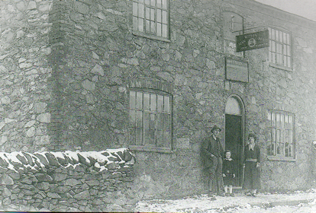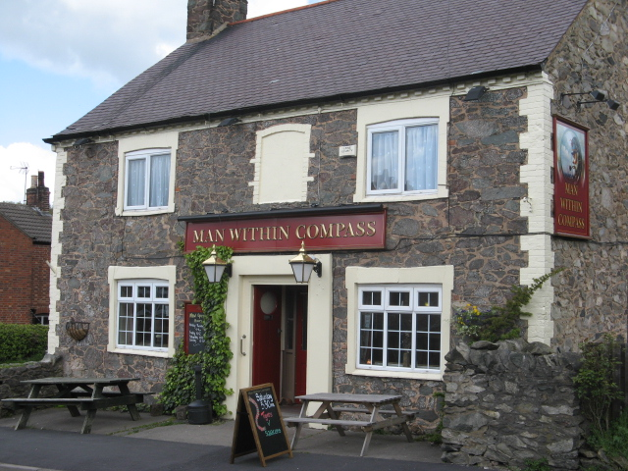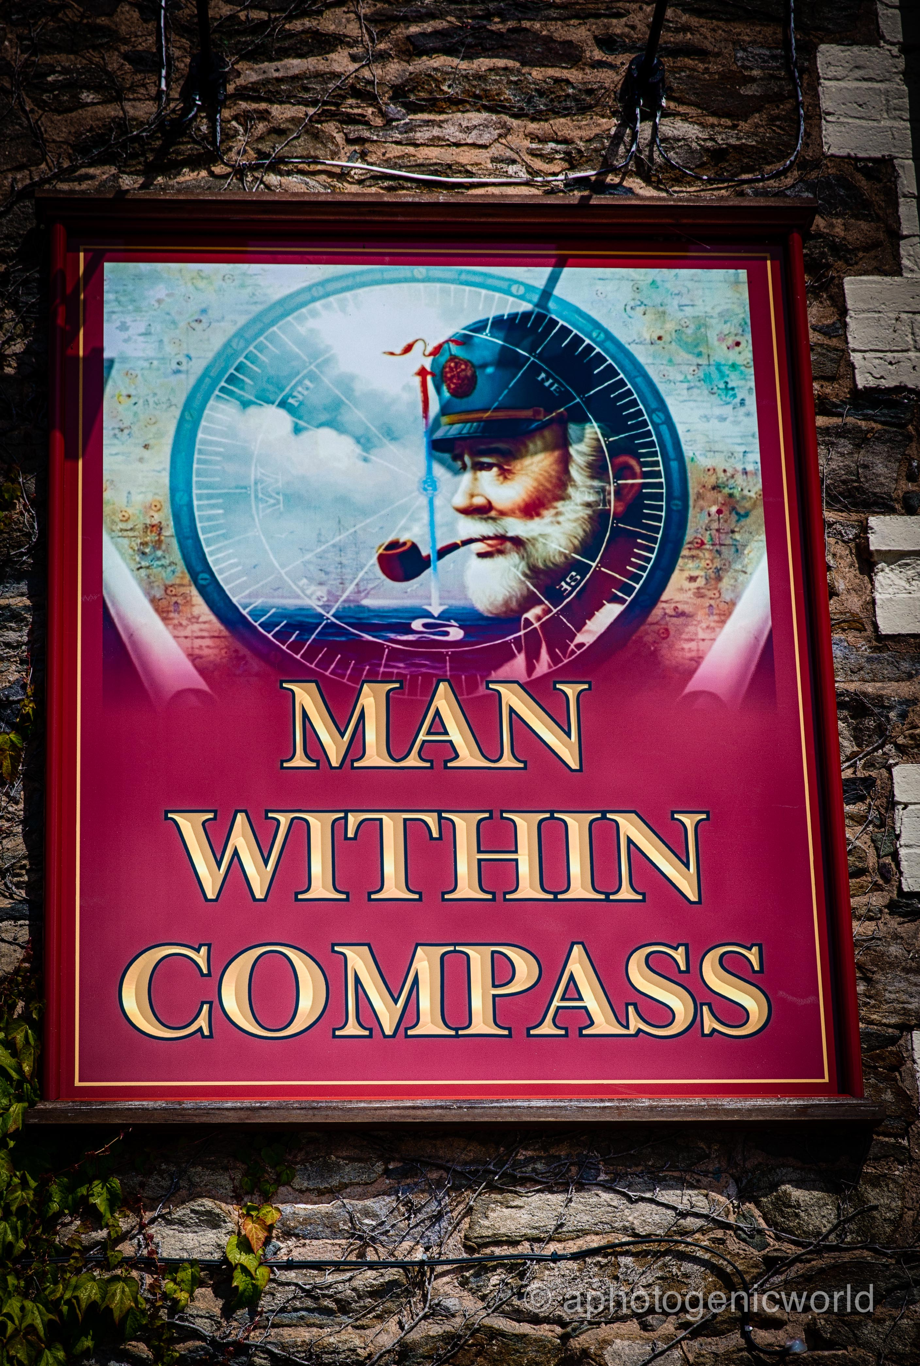
Man Within Compass (1920 - landlord Man Within Compass (the bitterman) MWC (sign)
John Warrington, wife Matilda &
son Sidney)

Location – Loughborough Road.

Man Within Compass landlords –
1872-97 Joseph Hornbuckle (beerhouse keeper & carrier)
(Note – most Directories list the name as the ‘Compass’)
1897 James Wileman
1899 William Stanyard (beerhouse keeper)
1901-07 Thomas & Ann Stanyard
- John Charles Fewkes
  - William Wileman
  - Zachariah Parker
  - John William & Matilda Warrington
  - Arthur Black
  - Walter Massey
  - Archibald Charles Mead
1939-42 Colin & Sarah Bosworth
1942-60 Sarah Bosworth
1960 Thomas Walter & Sophie Lees
1978-79 Roger Tregellas Tiddy
1979-81 Alan Armstrong
1981-82 John & Jenny Harvey
1982-87 Robert Alfred & Margaret Cox
1987-88 Keith Charles Barber
1988-89 Lorraine Philomena Cumming
1989 Stuart George Reynolds & Ken Wilson
1989-93 Pauline Laven
1993 David Edward Hill
1995-2000 Calvin & Valerie Bied
2001-02 Christopher & Marilyn Thurgar
2002 Pacey Helen & Michel Clinton
2003-05 John & Judith Green
2005-10 Margaret Lewis
2010-11 Aaron Moffat & Mark Taylor
2011-12 Mick & Sarah Lehane

