King William IV / Porto Gomes - Mountsorrel

(Note – details reflect research to date and that the records for missing dates are not currently available)

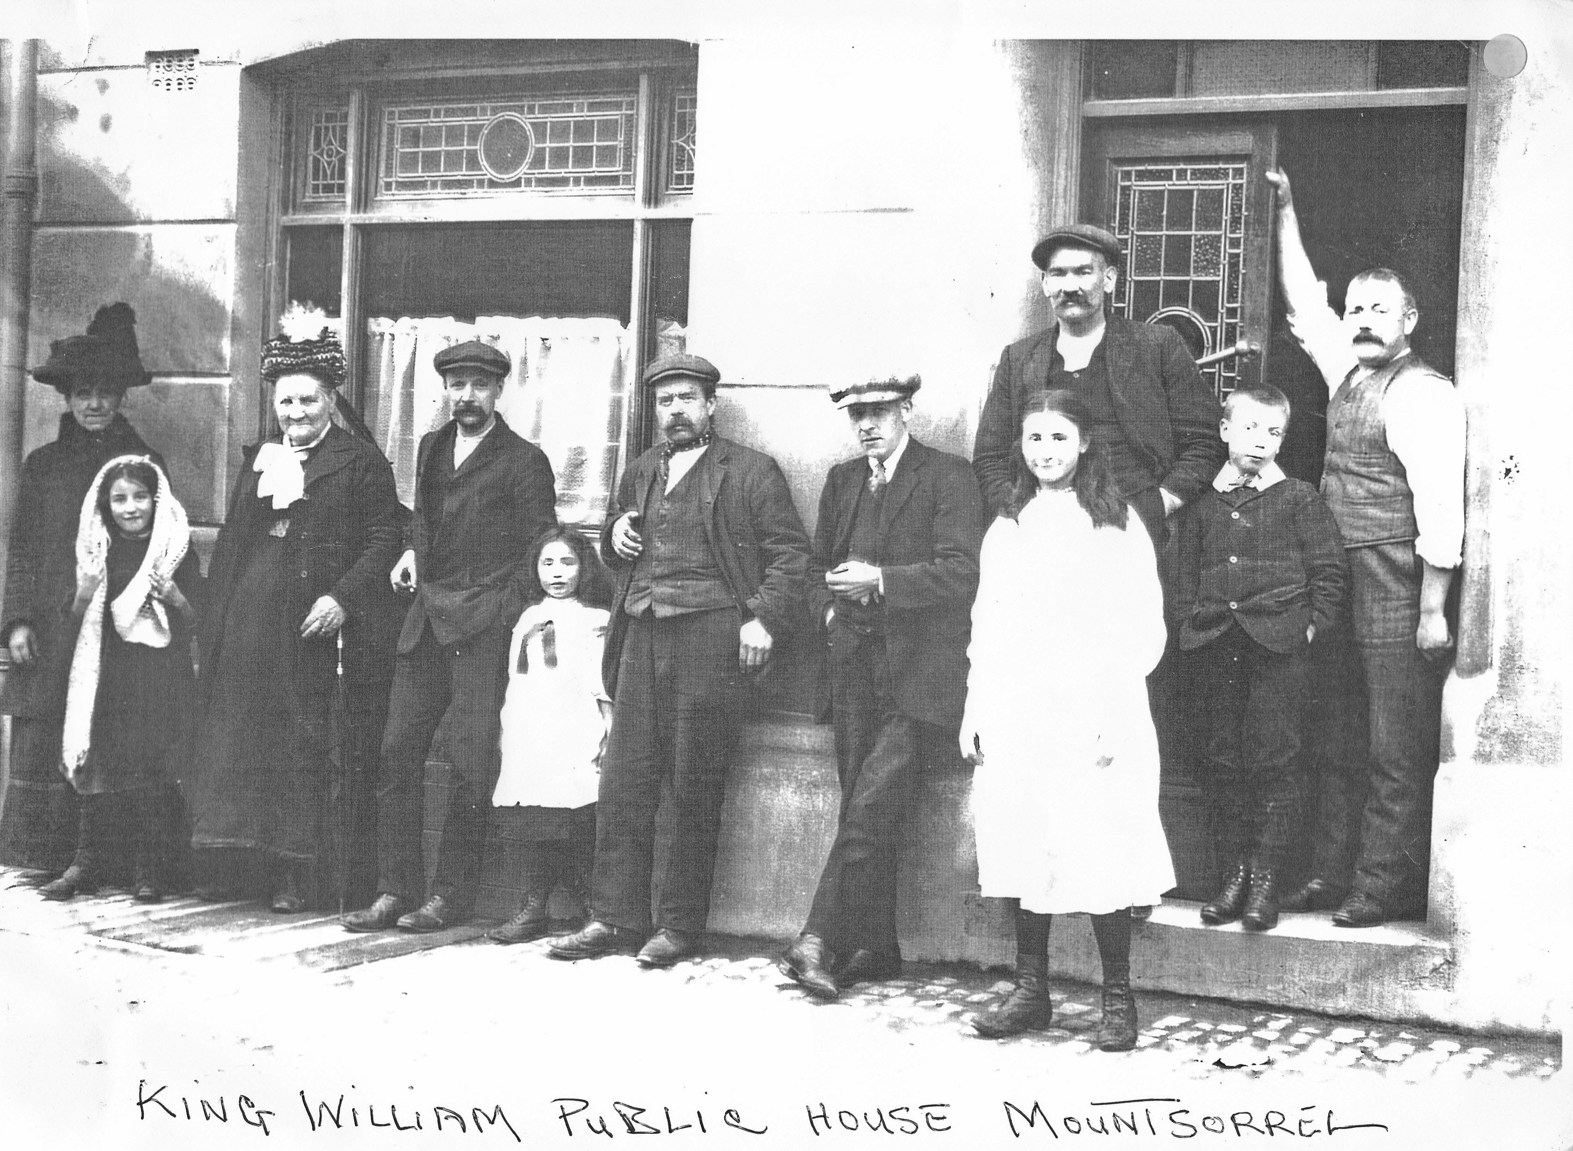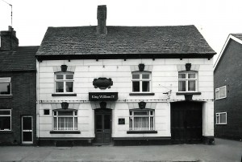
King William IV (Mountsorrel Archive) King William IV (Mountsorrel Archive)

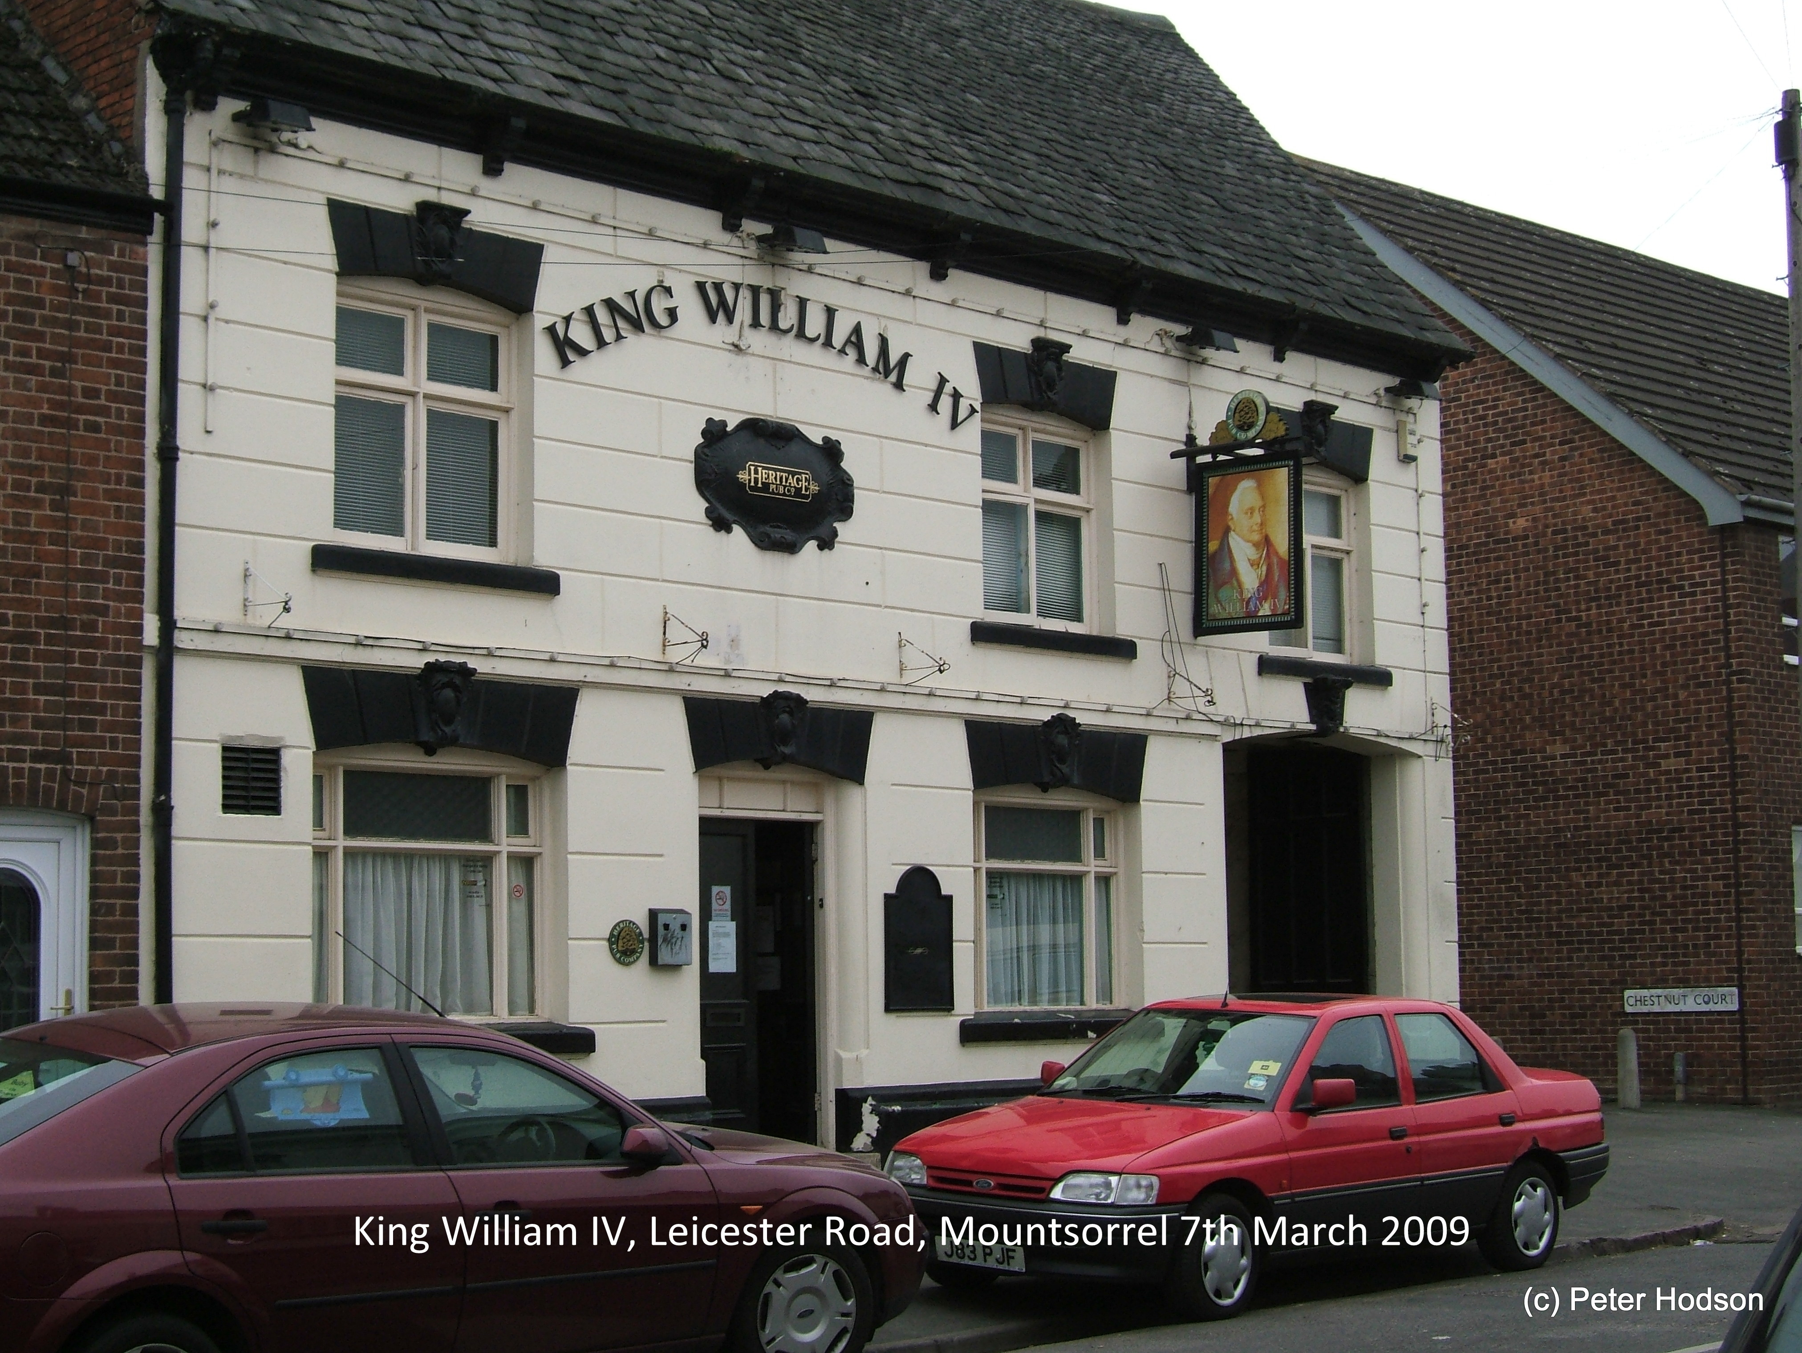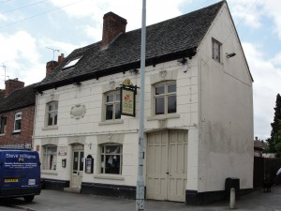
King William IV (Mountsorrel Archive) Porto Gomes (Mountsorrel Archive)

Location – 154 Leicester Road.

King William IV landlords –
1835-46 John Brown (& post office)
1854-70 George Duncan
1875-81 Thomas Priestley Odams
(Note – the 1875, 76 & 81 Directories list the name as the ‘William IV’)
(Note – the 1878 & 80 Directories list the name as the ‘King William III’)
  - Charles Gilbert (victualler)
  - Arthur Smith (victualler)
  - John Thomas Blackie (victualler)
  - George Mason (victualler)
  - ‘King William IV’ listed but no landlord named
  - John Bodycote
1932-41 Charles Henry Bower

2009 CLOSED

Porto Gomes landlords –
- RE-OPENED as a Portuguese Bistro Bar

2013 CLOSED

